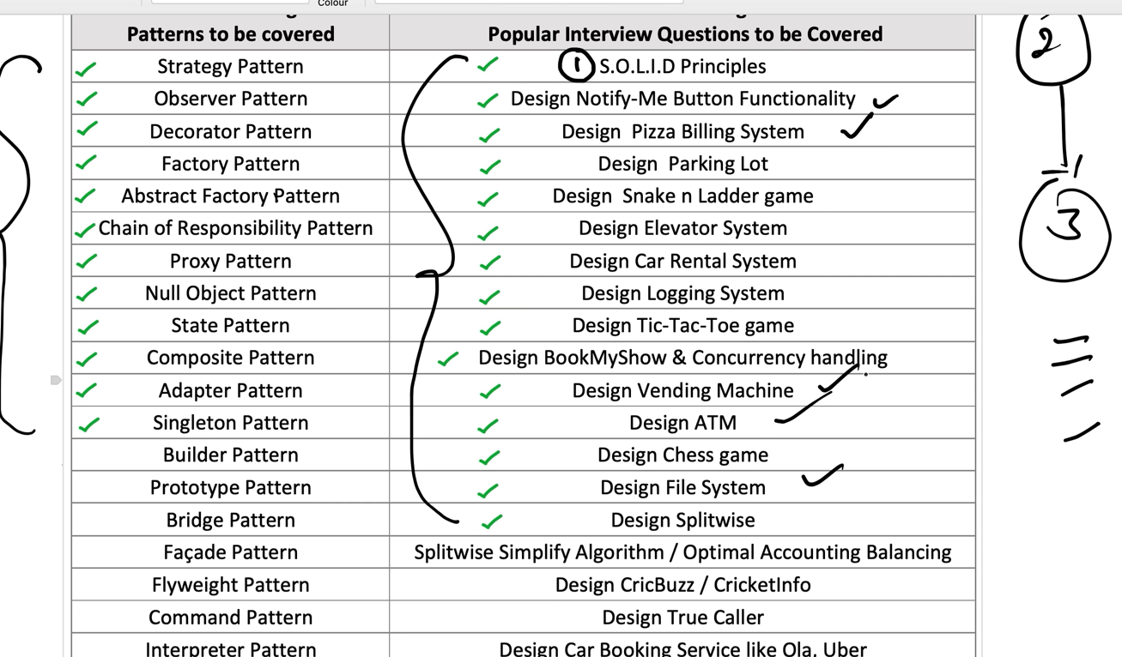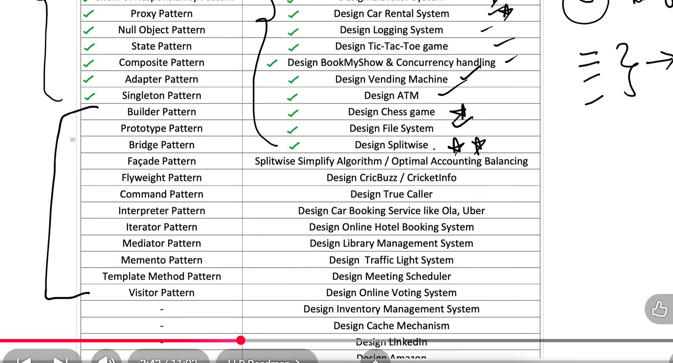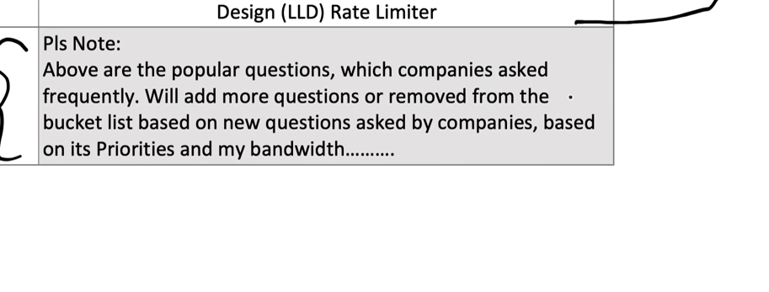

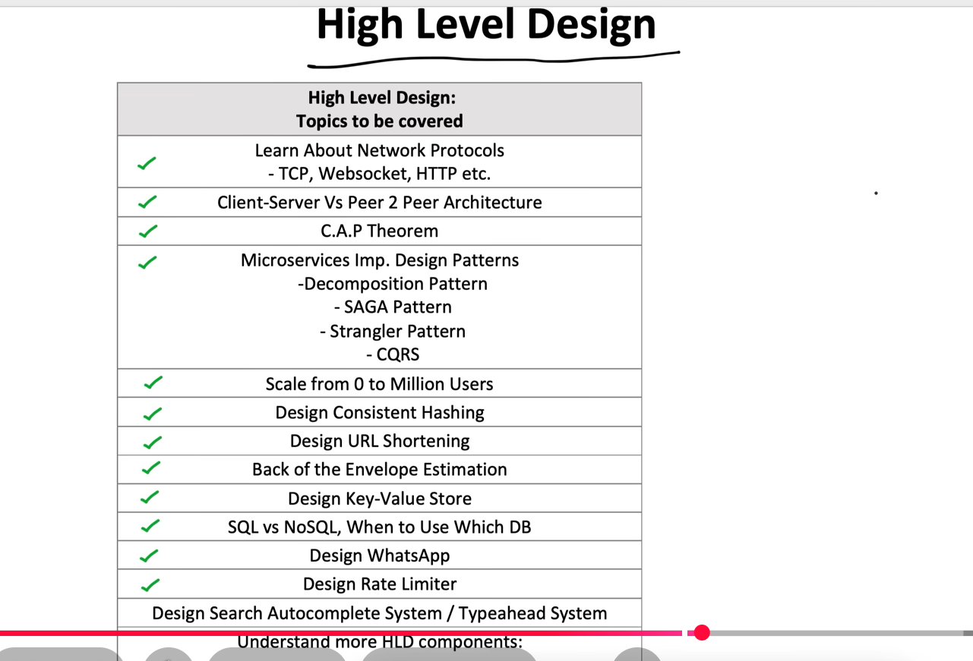
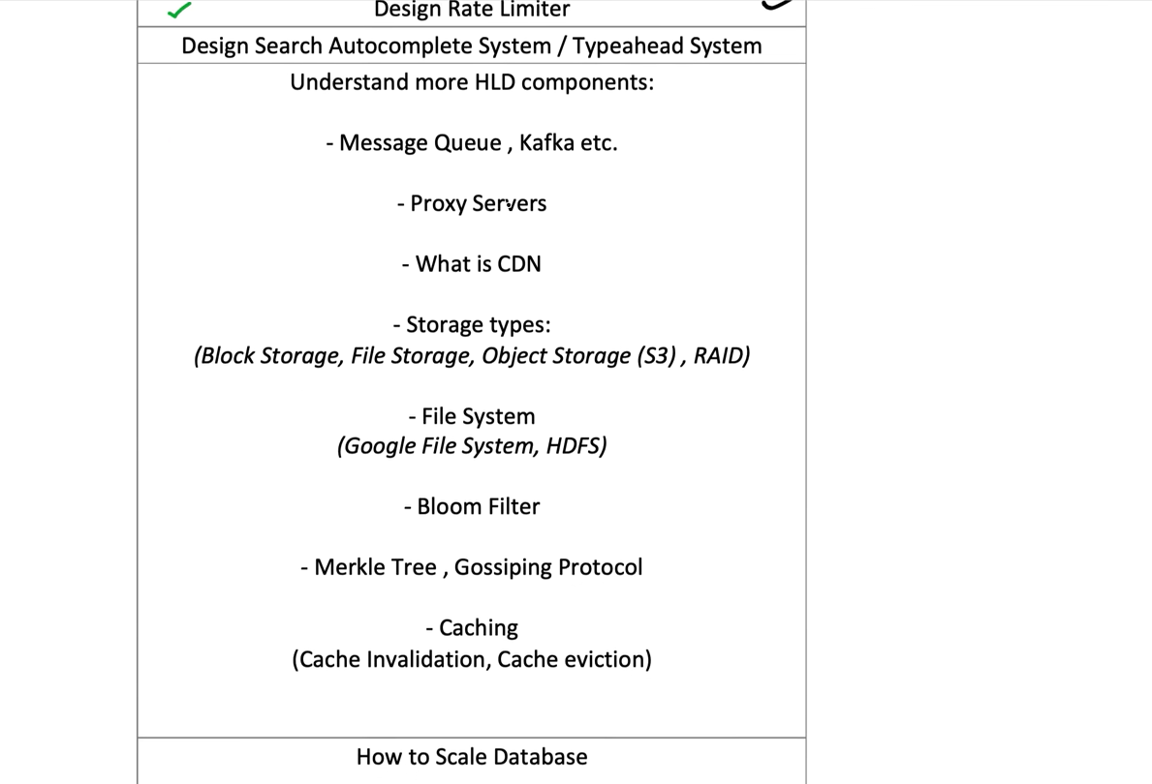

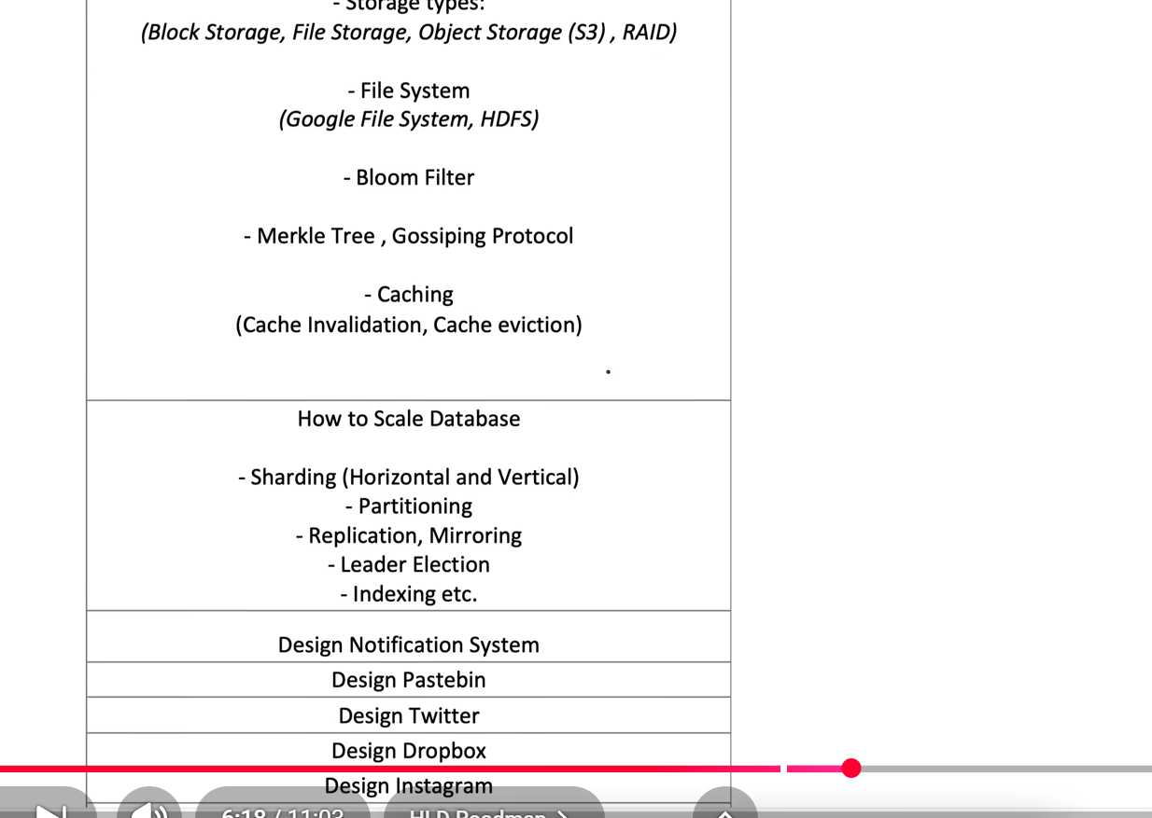
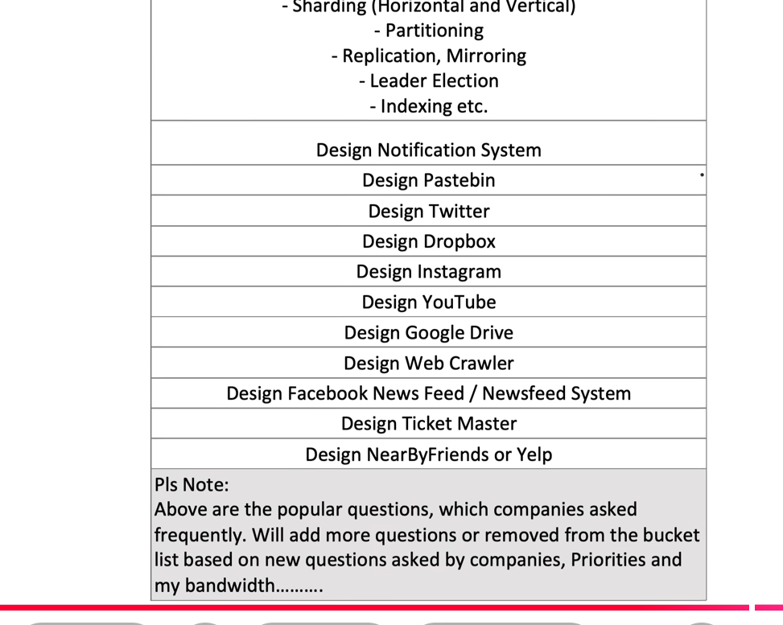
First 15 days LLD focused
Day -1(LLD)
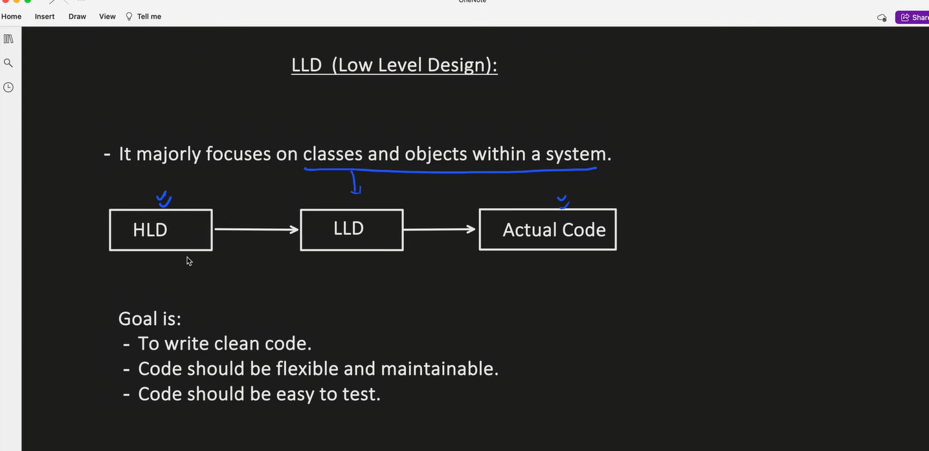
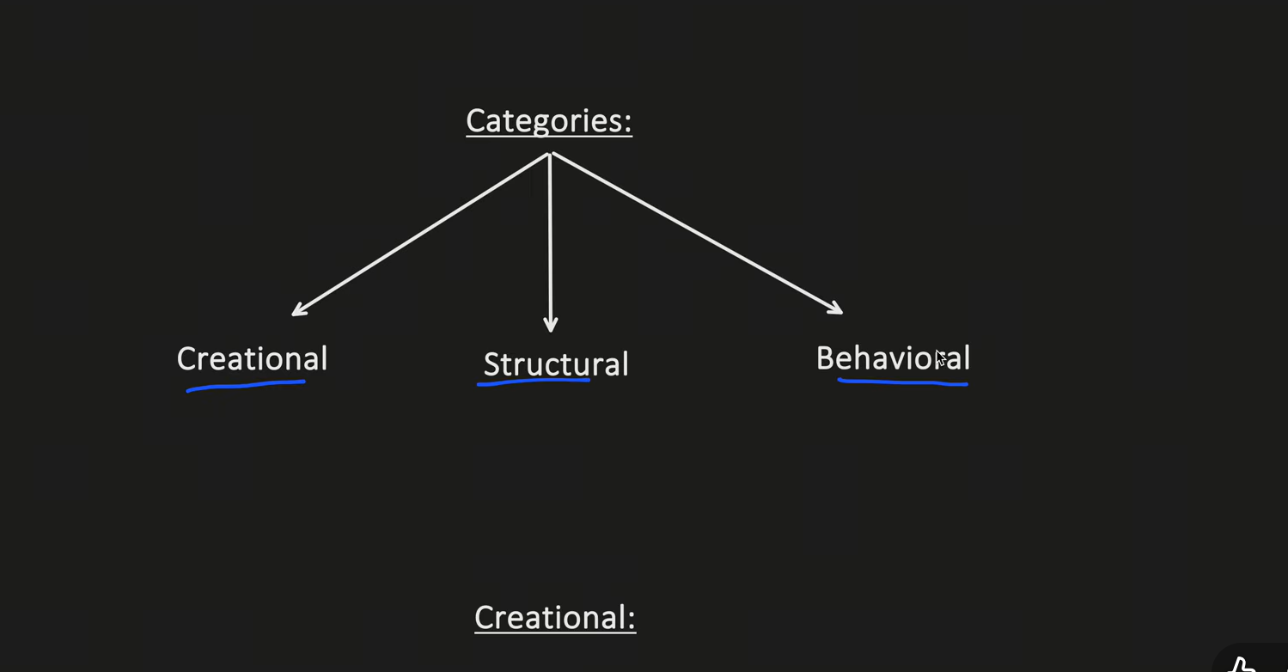

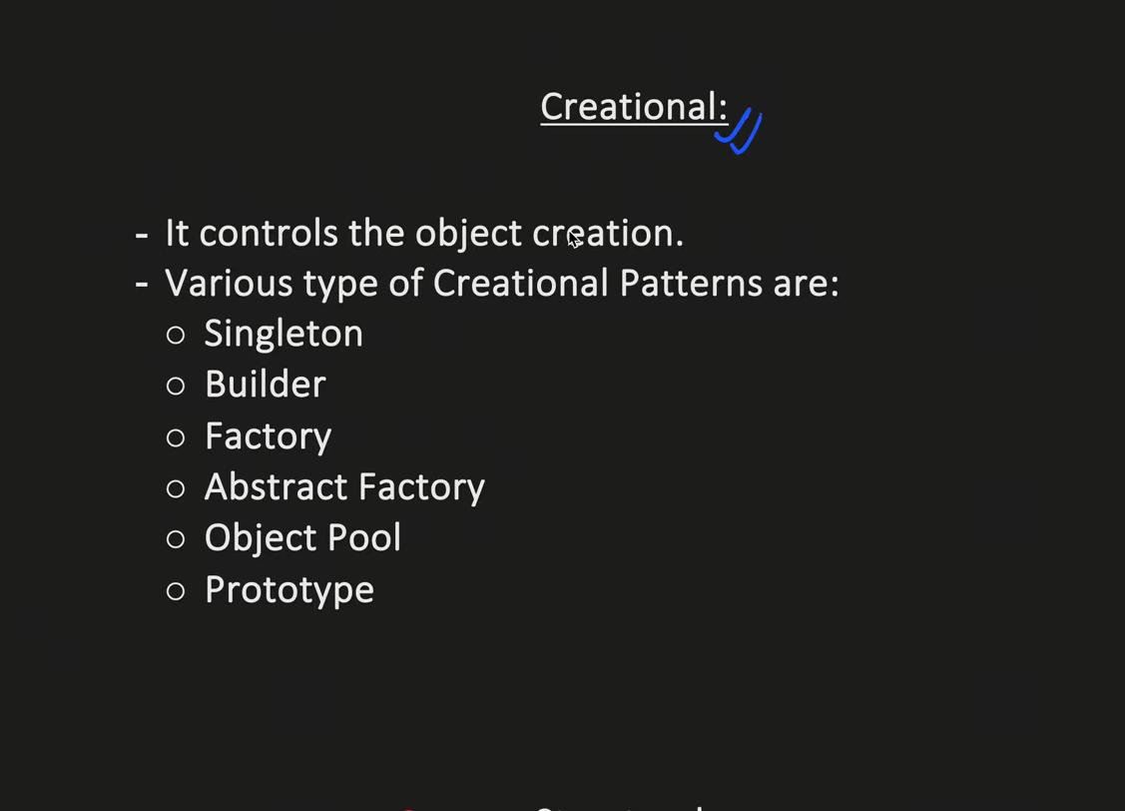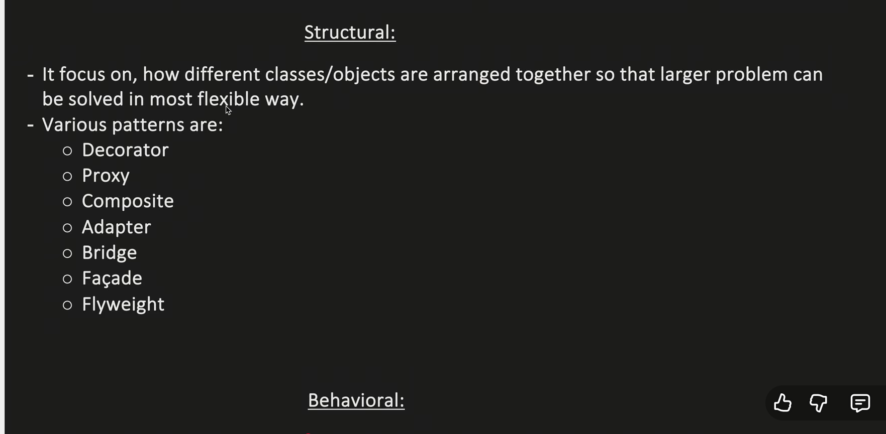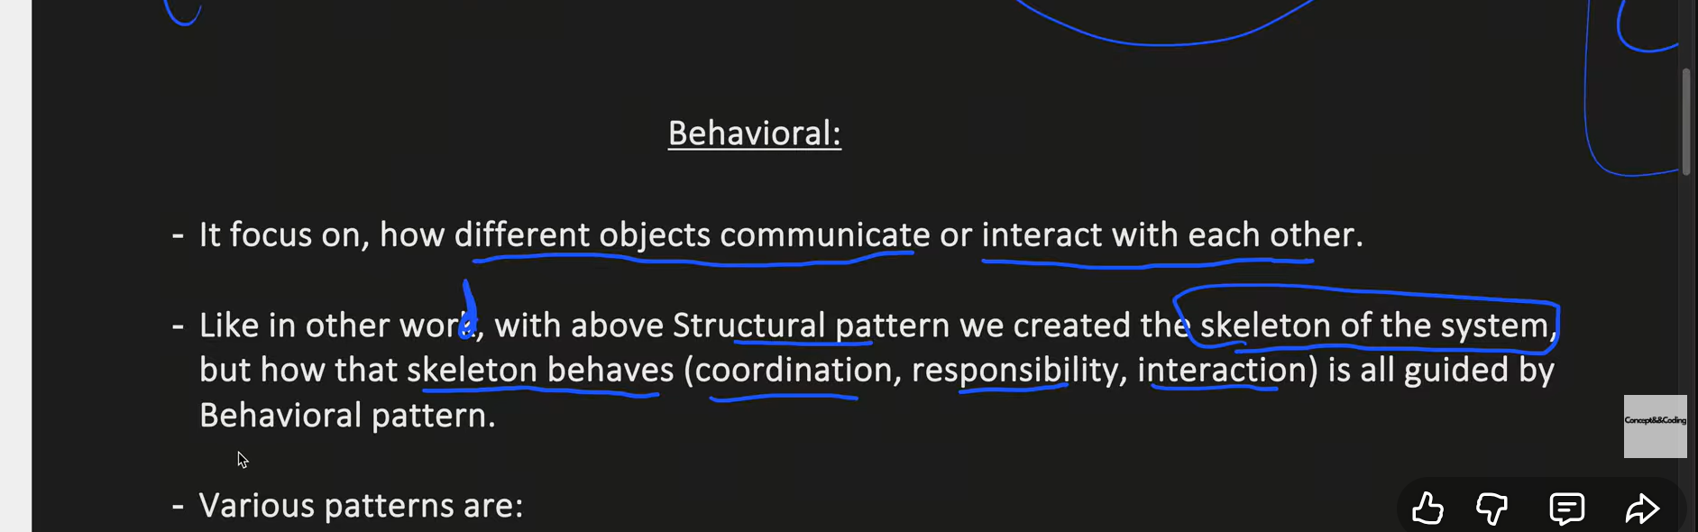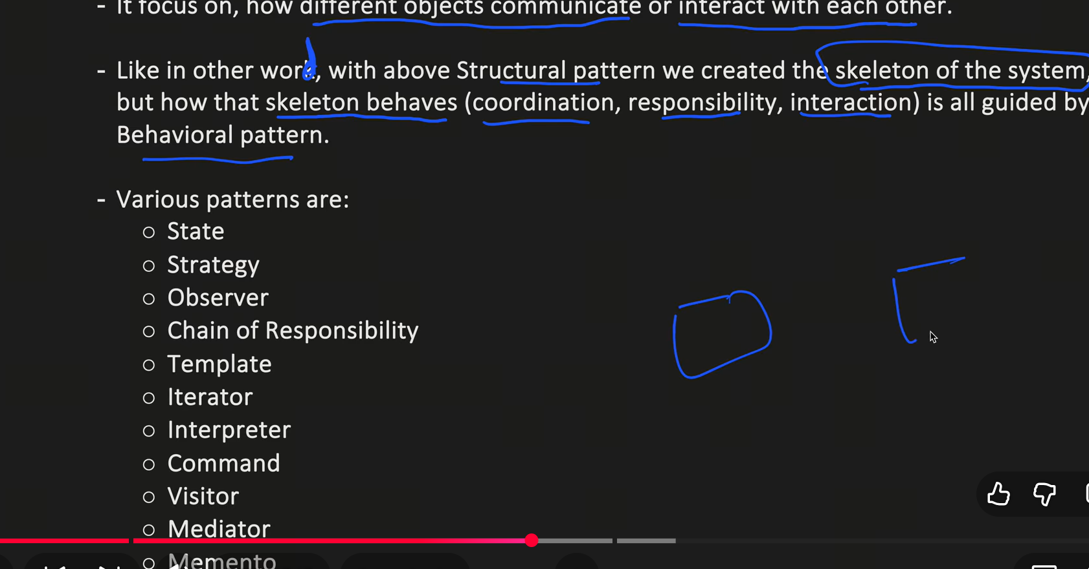

Imagine a Car
A car has a Driver, Engine, and Wheel.
Now ask: what happens to one object when the other object is gone?

1. Association = "I know you"
Imagine:
Driver ───────── Car
A driver drives a car.
But the driver and car are completely independent.
Driver
↓
can exist without Car

Car
↓
can exist without Driver
In Java:
class Driver {
void drive(Car car) {
System.out.println("Driving");
}
}

class Car {
}
The driver uses the car.
But the driver doesn't own the car.

Think:
Association = "I use/know you."
Examples:
Teacher ─── Student
Doctor ─── Patient
Customer ─── Order
Driver ─── Car

2. Aggregation = "I have you, but you can live without me"
Now imagine a Company and Employee.
Company
|
| has
↓
Employee
A company has employees.
But suppose the company closes tomorrow.
Company ❌
Does the employee disappear?
No.
The employee can join another company.
Employee ✅
So:
Company
|
├── Employee A
├── Employee B
└── Employee C
The company has employees, but doesn't completely own their existence.
That's aggregation.

Java
class Employee {
String name;

Employee(String name) {
this.name = name;
}
}

class Company {

List<Employee> employees;

Company(List<Employee> employees) {
this.employees = employees;
}
}
Notice:
Employee e1 = new Employee("John");
Employee e2 = new Employee("Mike");

Company company =
new Company(List.of(e1, e2));
Employees were created outside the Company.
Therefore:
Company ❌

Employee John ✅
Employee Mike ✅

Think:
Aggregation = "I have you, but you can survive without me."

3. Composition = "You belong to me"
Now imagine an Order and OrderItem.
Order
|
├── OrderItem
├── OrderItem
└── OrderItem
Suppose you have:
Order #101

Pizza ₹300
Burger ₹200
Coke ₹50
The OrderItem exists because of that particular order.
If Order #101 is permanently removed:
Order #101 ❌
Its order items also have no reason to exist independently.
OrderItem ❌
OrderItem ❌
OrderItem ❌
That's composition.

Java
class OrderItem {

private String product;
private int price;

OrderItem(String product, int price) {
this.product = product;
this.price = price;
}
}
Now:
class Order {

private List<OrderItem> items;

Order() {
items = new ArrayList<>();

items.add(new OrderItem("Pizza", 300));
items.add(new OrderItem("Burger", 200));
}
}
The Order creates its own OrderItems.
Conceptually:
Order
├── OrderItem
└── OrderItem
The items belong to that Order.

Think:
Composition = "You are a part of me."

Now compare all 3
Imagine these three situations:

Association
Doctor ───── Patient
Doctor knows patient.
Both can exist independently.
"I know you."

Aggregation
Company ◇──── Employee
Company has employee.
Employee can exist without company.
"I have you."

Composition
Order ◆──── OrderItem
Order owns order items.
OrderItem belongs to the order.
"You are a part of me."

The easiest trick to remember
Whenever you see two classes, ask:

Question 1
Is one simply using/knowing the other?
Doctor → Patient
➡️ Association

Question 2
Does one have the other, but the other can survive independently?
Company → Employee
➡️ Aggregation

Question 3
Is the other object actually a part of the first object's lifecycle?
Order → OrderItem
➡️ Composition

One final real-world example
Think about your house:
You ───────── House
You live in a house.
That's association.
Company ◇──── Employee
Company has employees, but employees can leave.
That's aggregation.
House ◆──── Room
A room is considered a part of that particular house.
That's composition.
So memorize this:
ASSOCIATION
"I know/use you"

AGGREGATION
"I have you, but you can live without me"

COMPOSITION
"You are a part of me"
The biggest thing to understand is lifecycle/ownership. That's what interviewers are usually testing when they ask about these three.

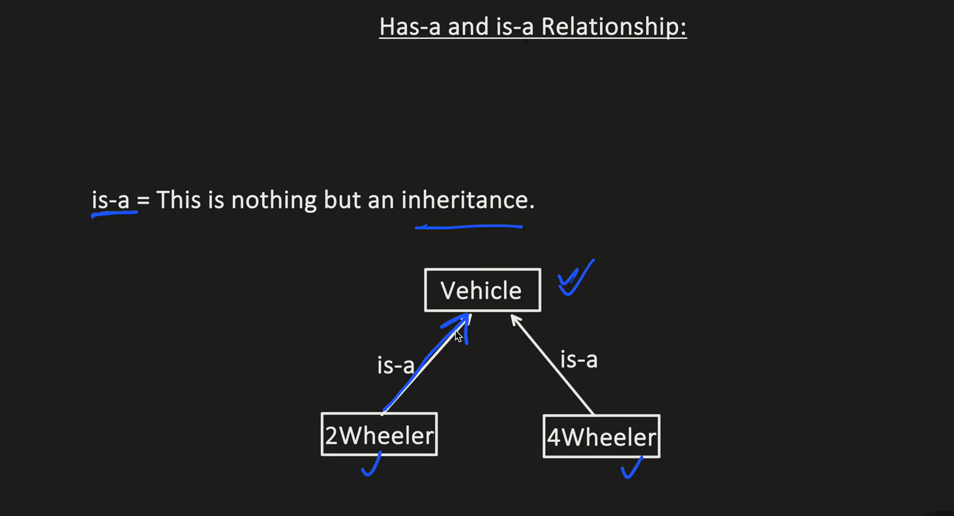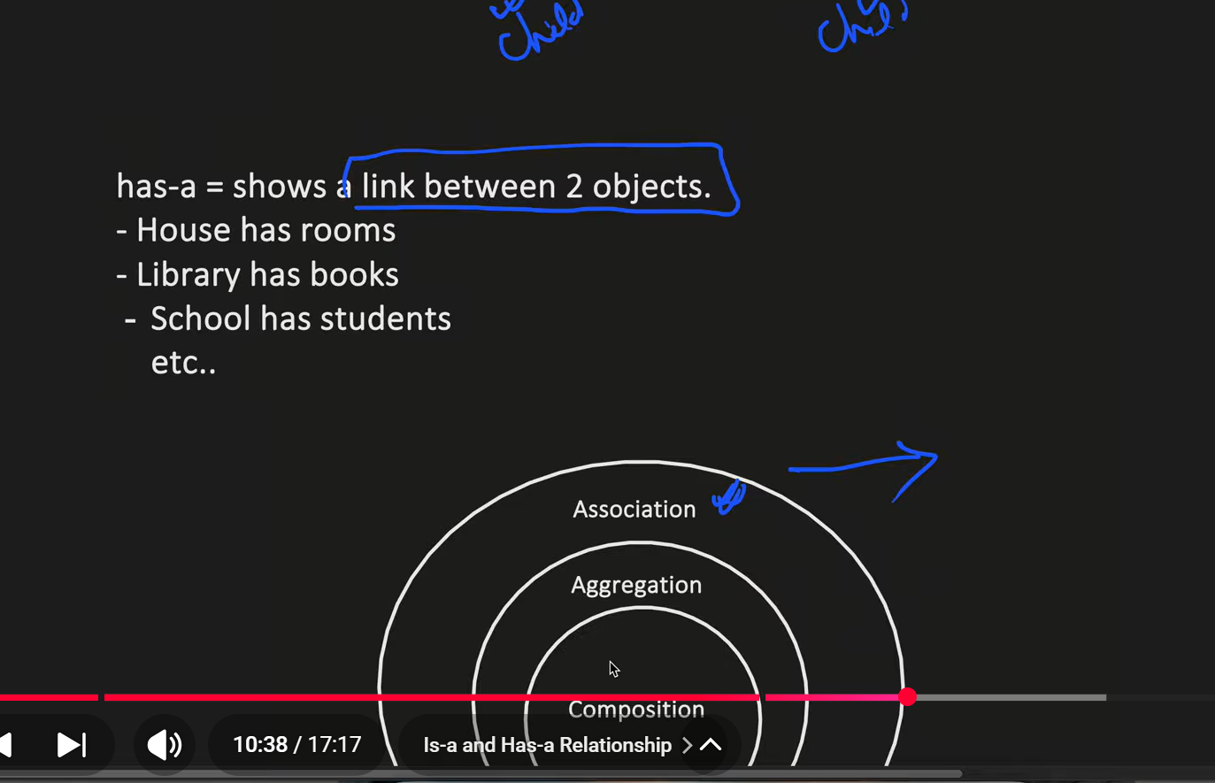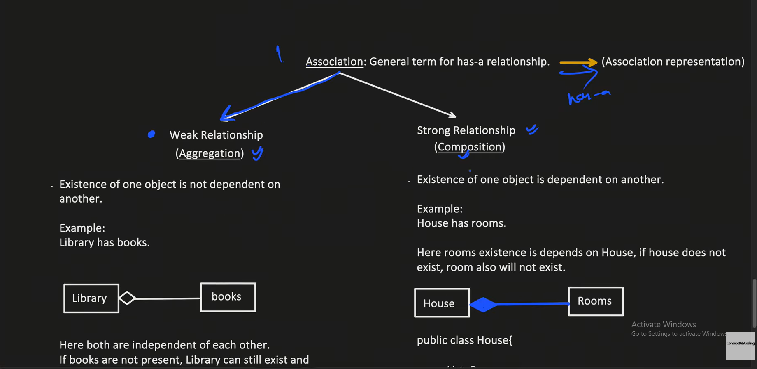

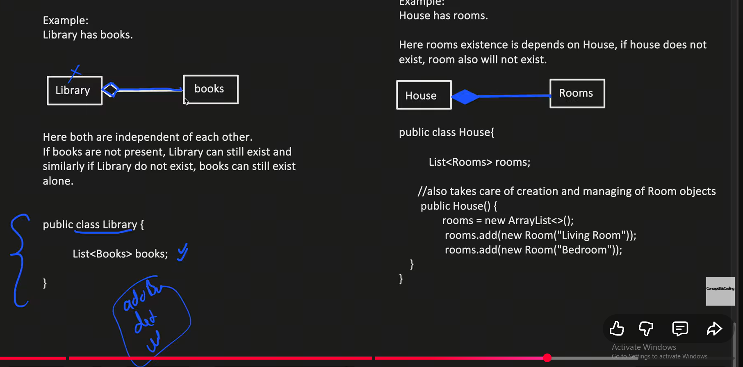
Day 01,02
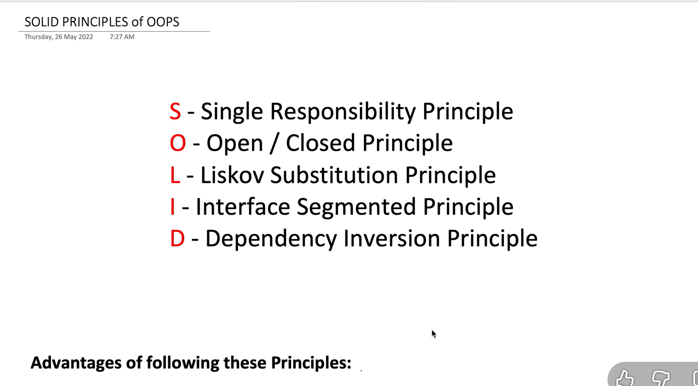 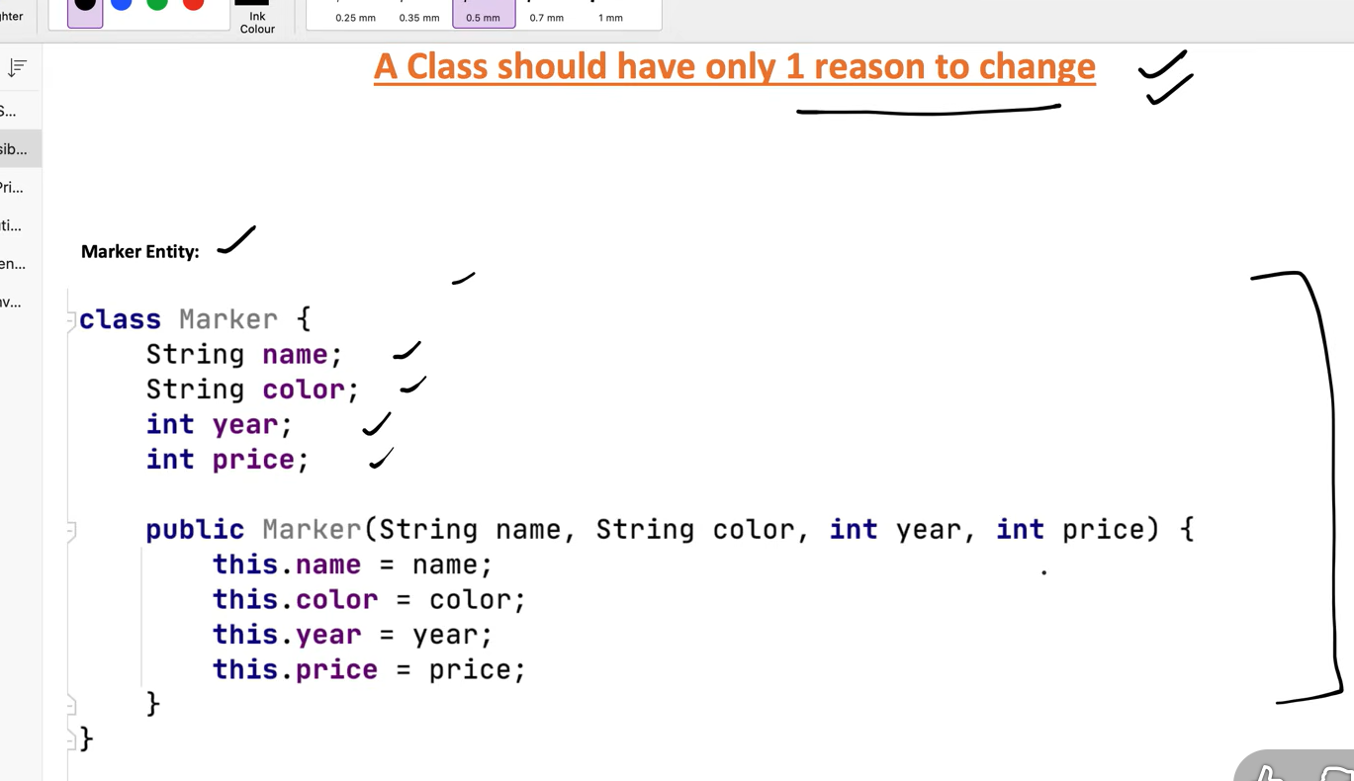
this clas don’t has single reason to change
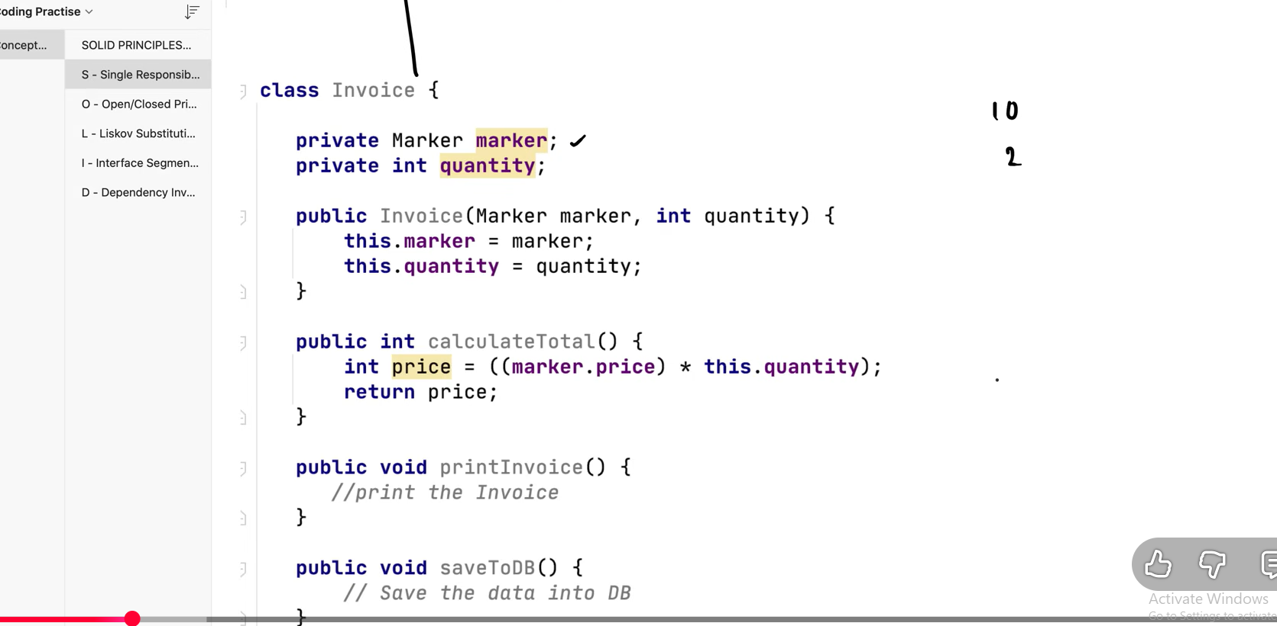
Now each class has single reason to change
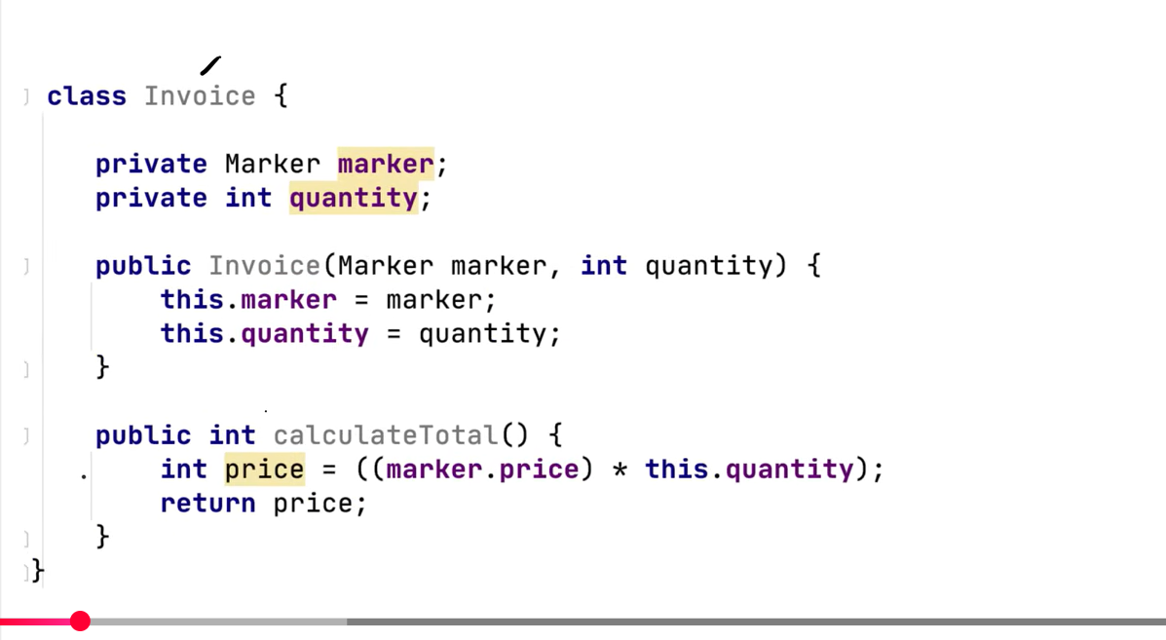
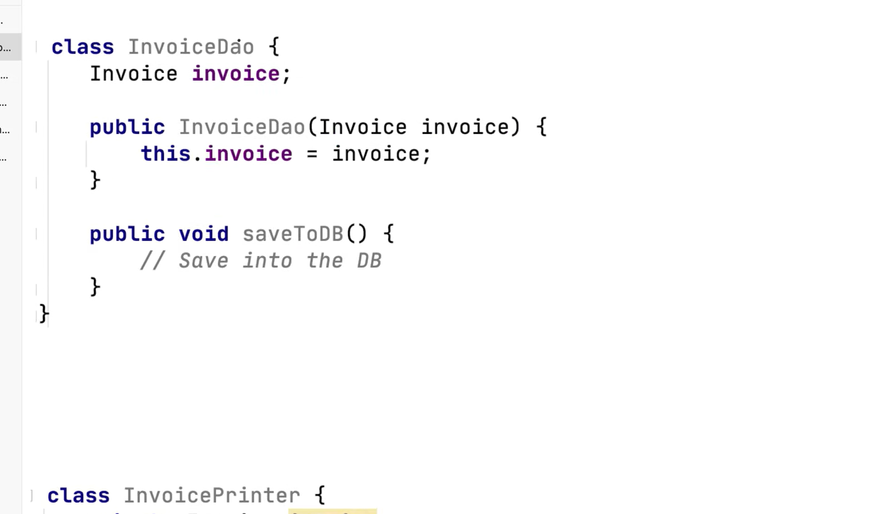
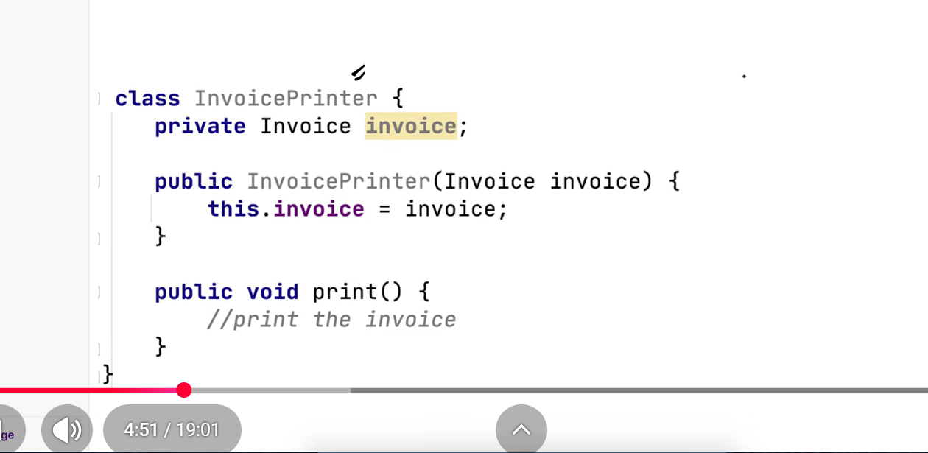
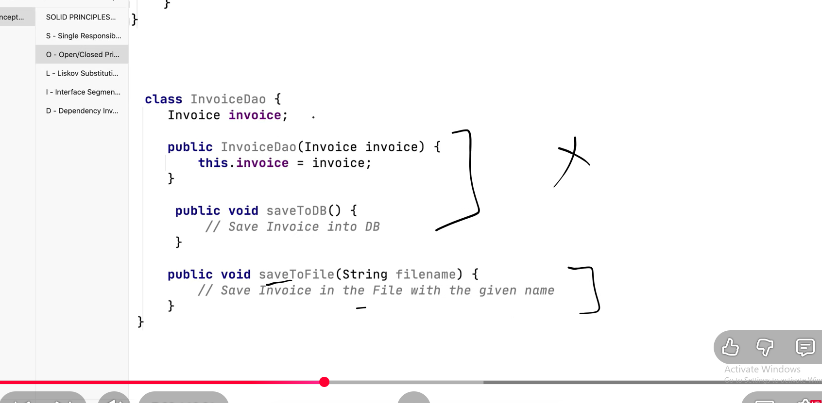
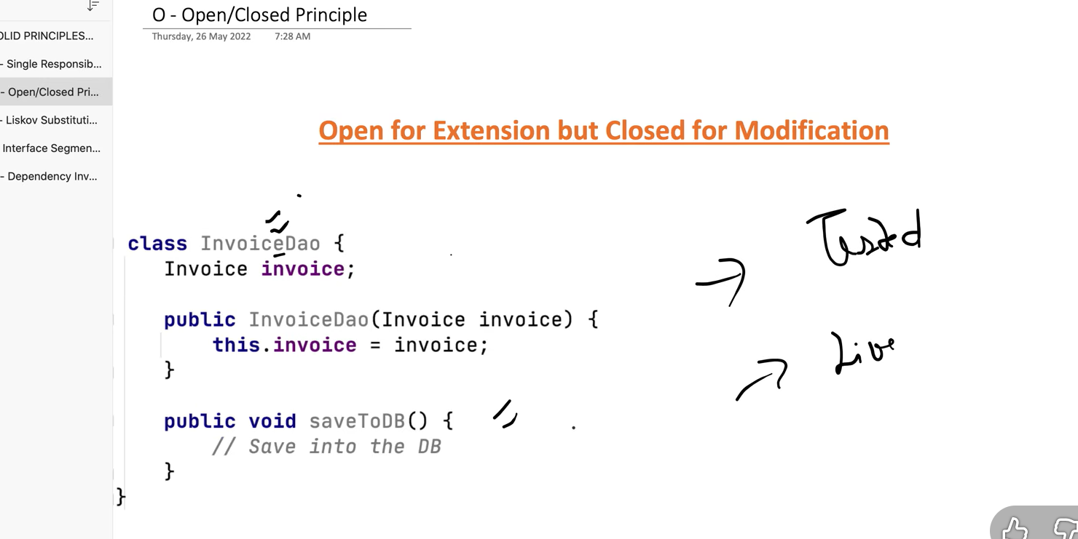
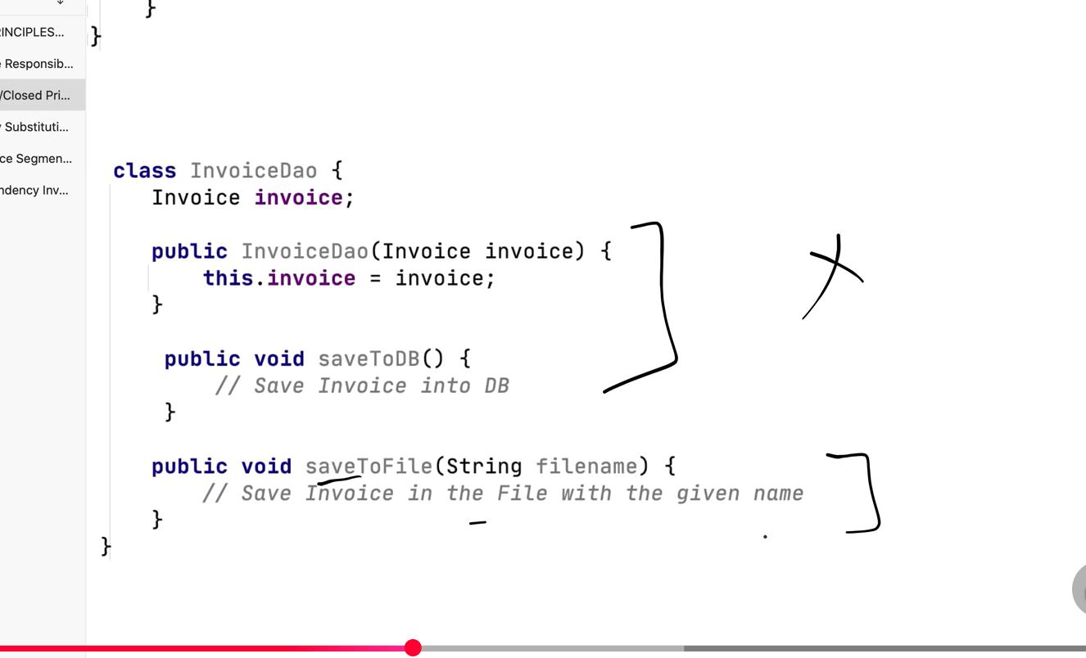
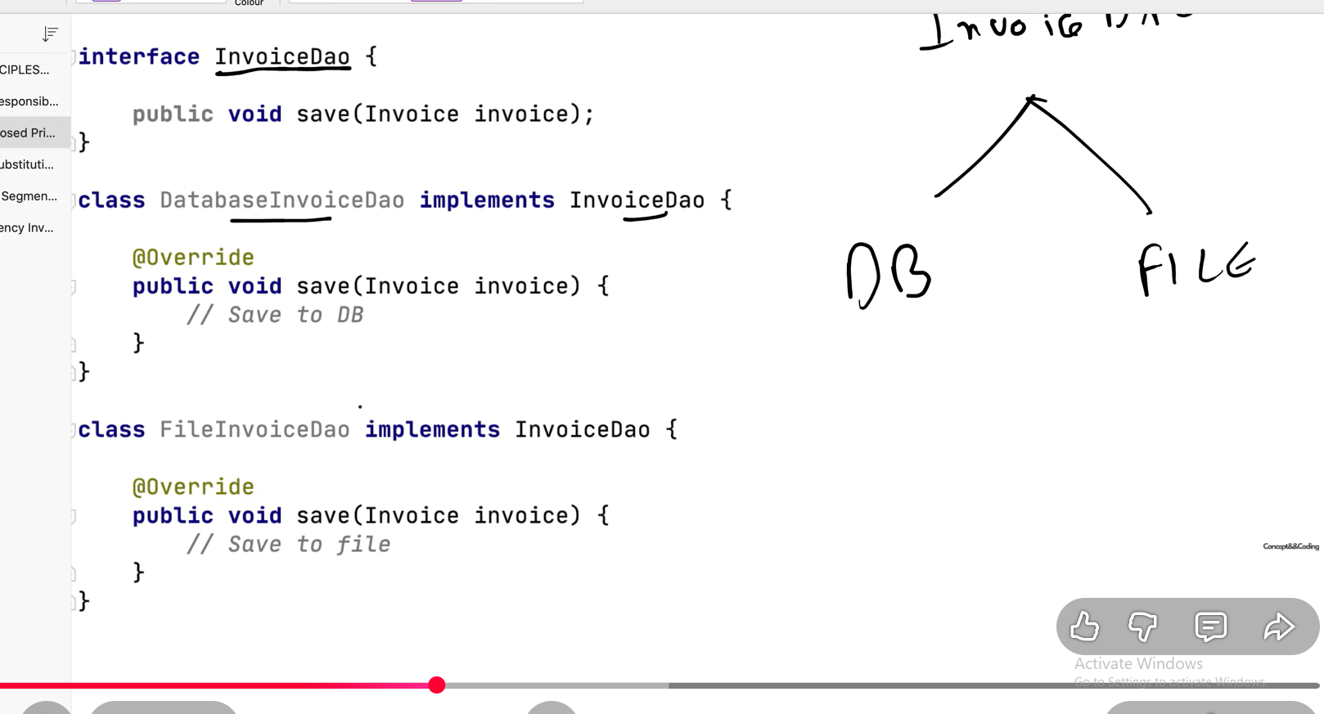
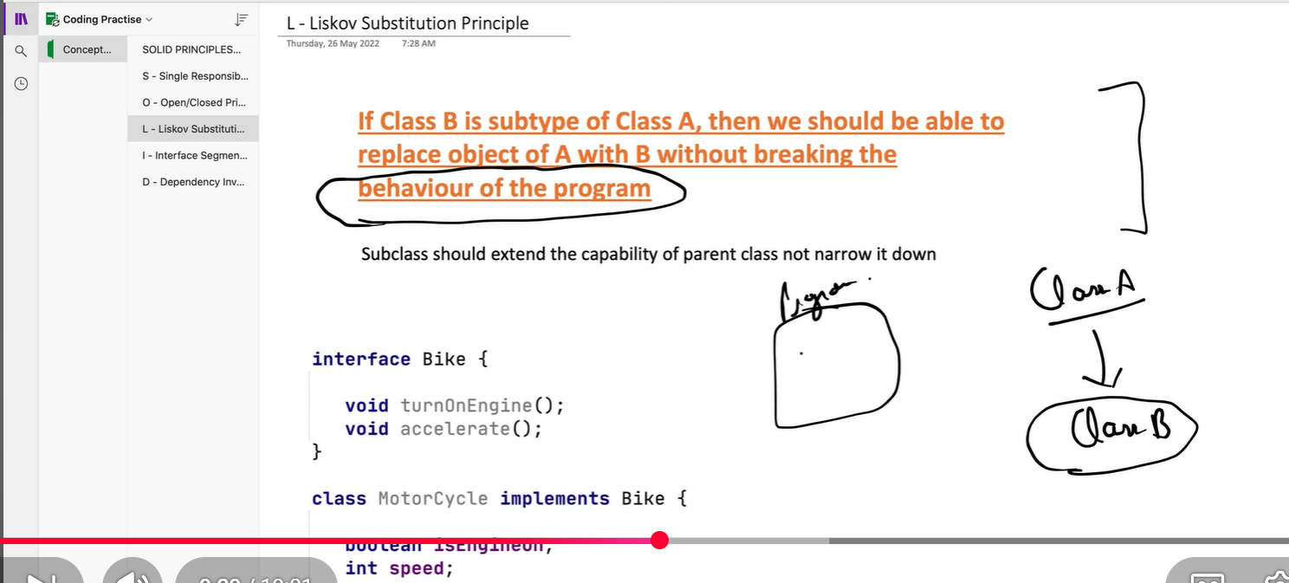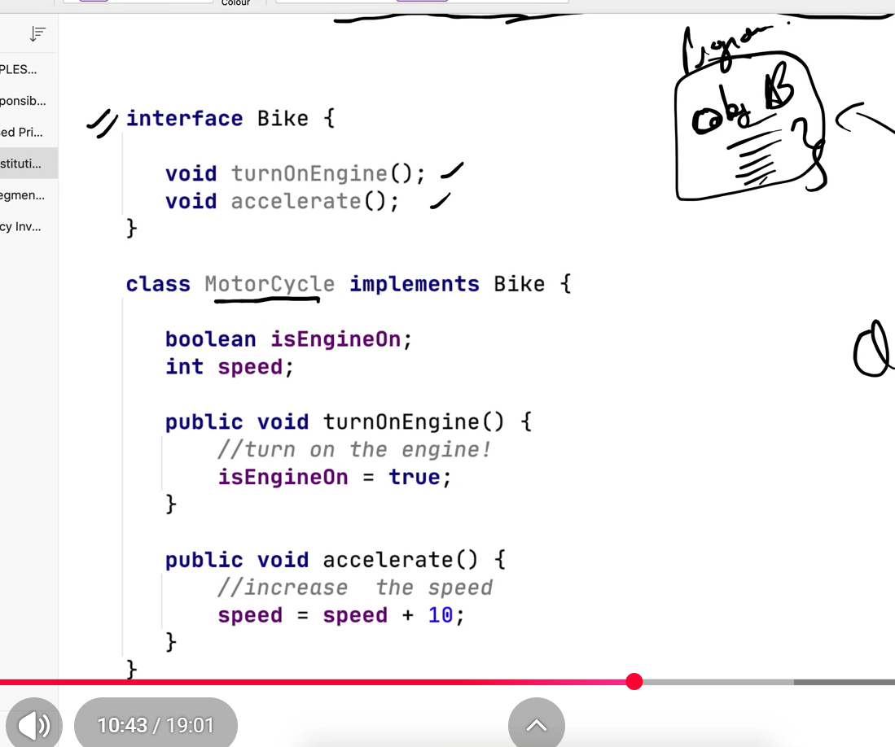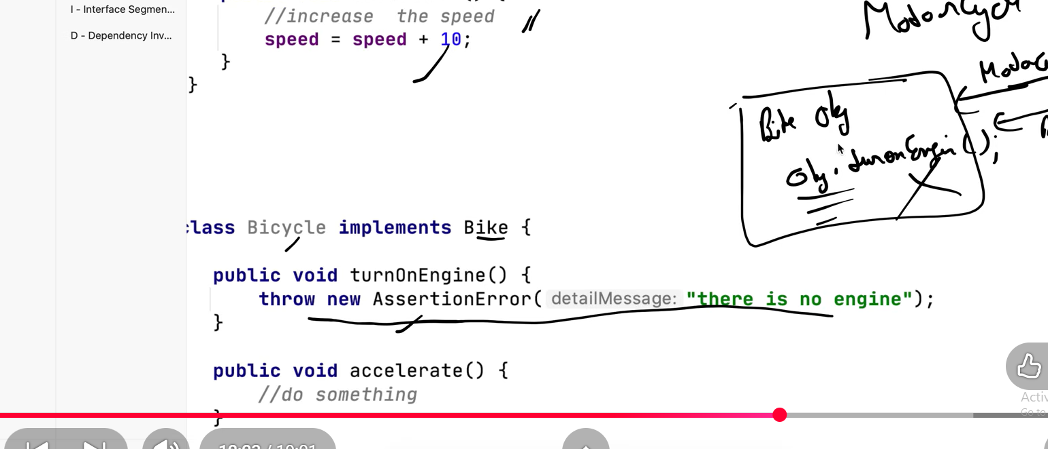
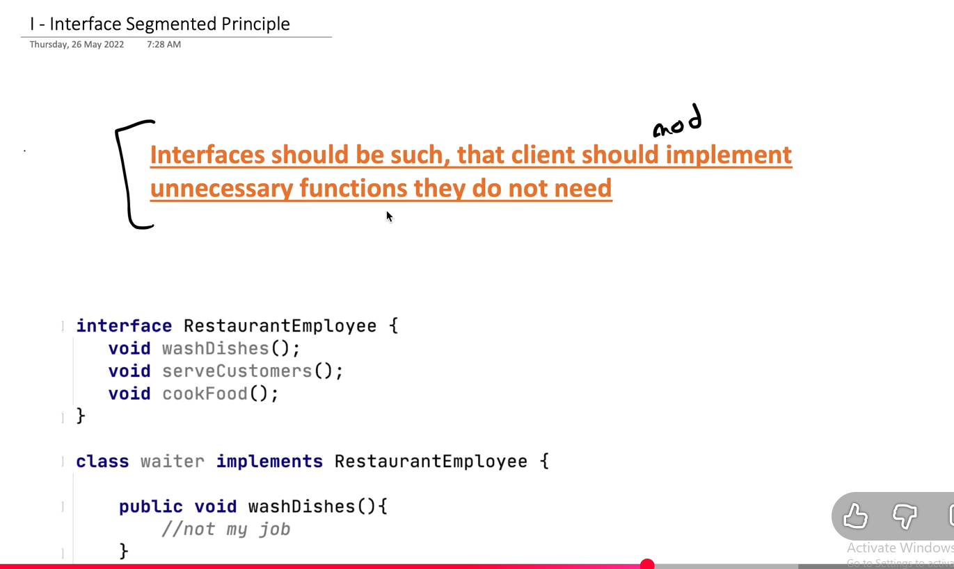
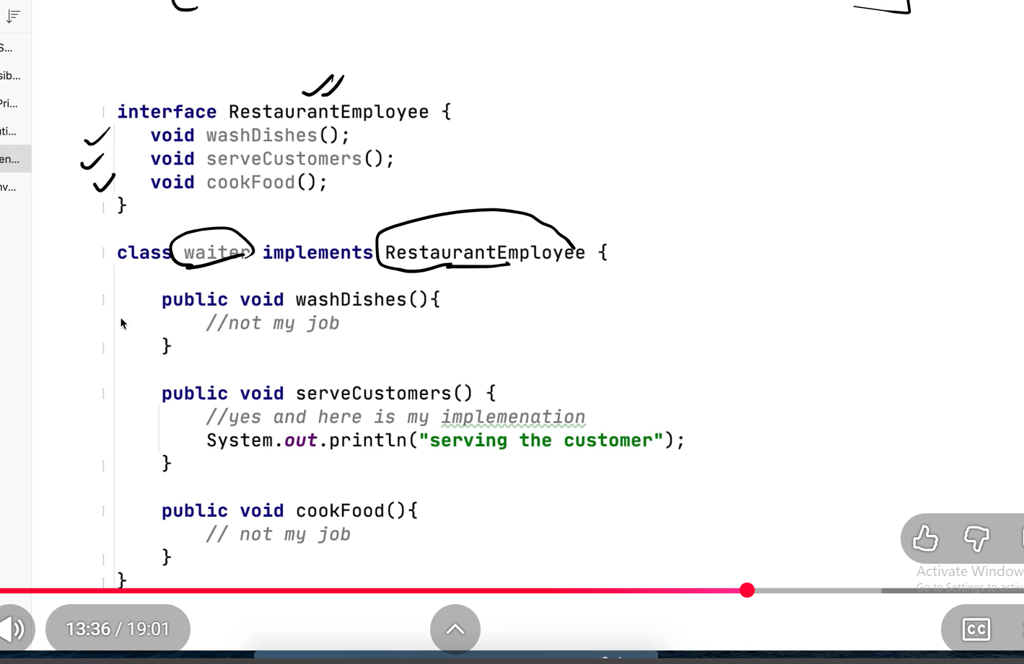
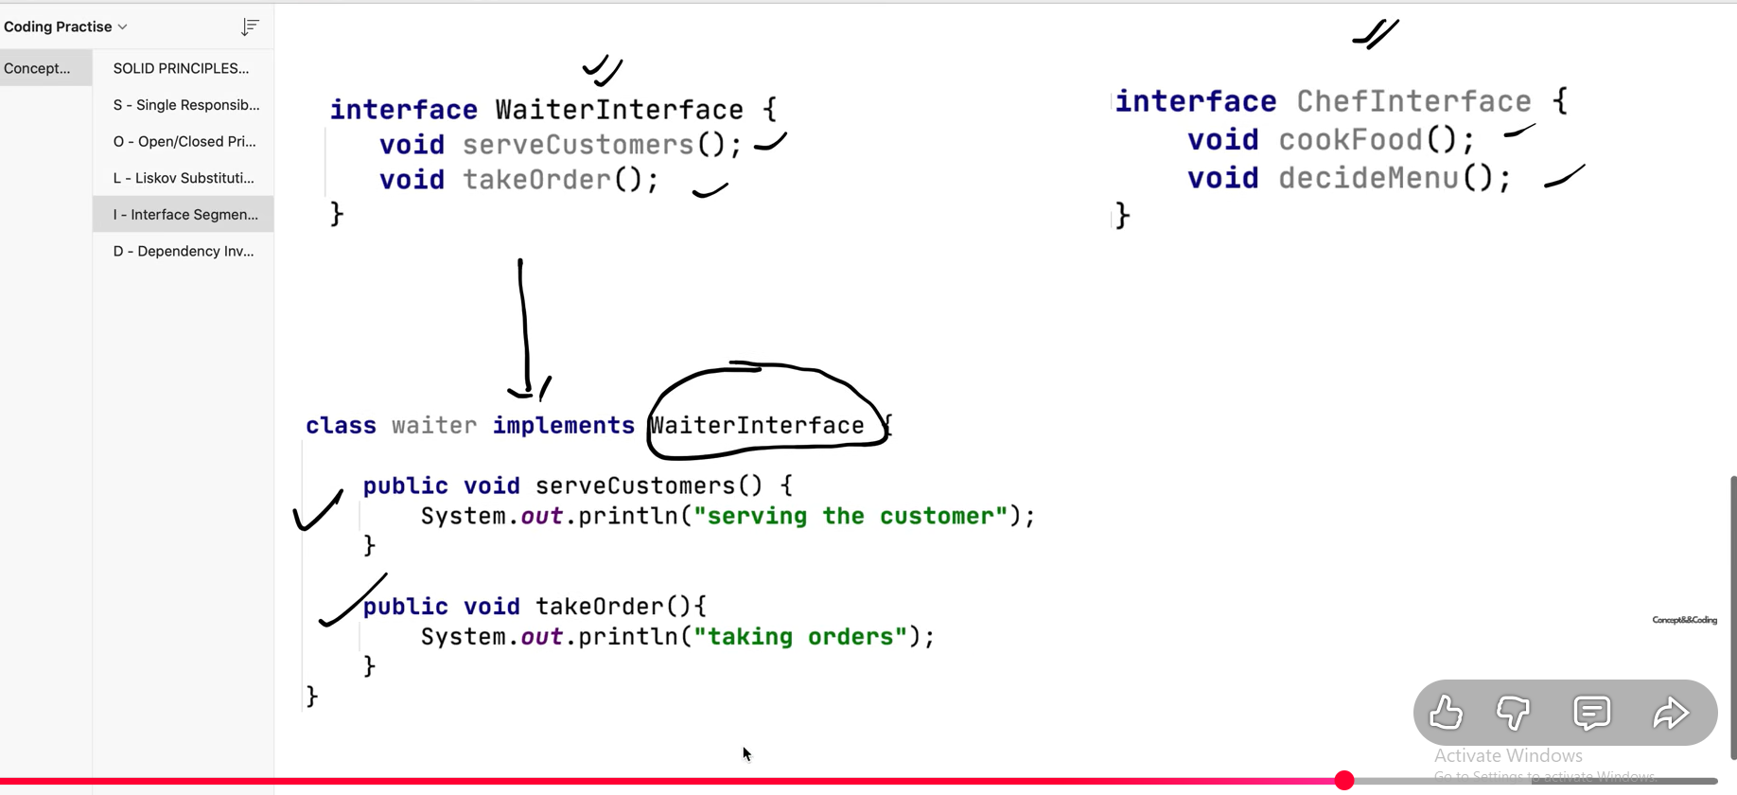
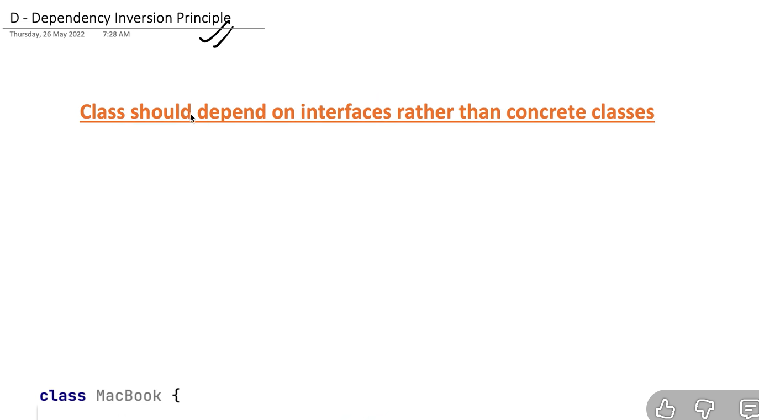 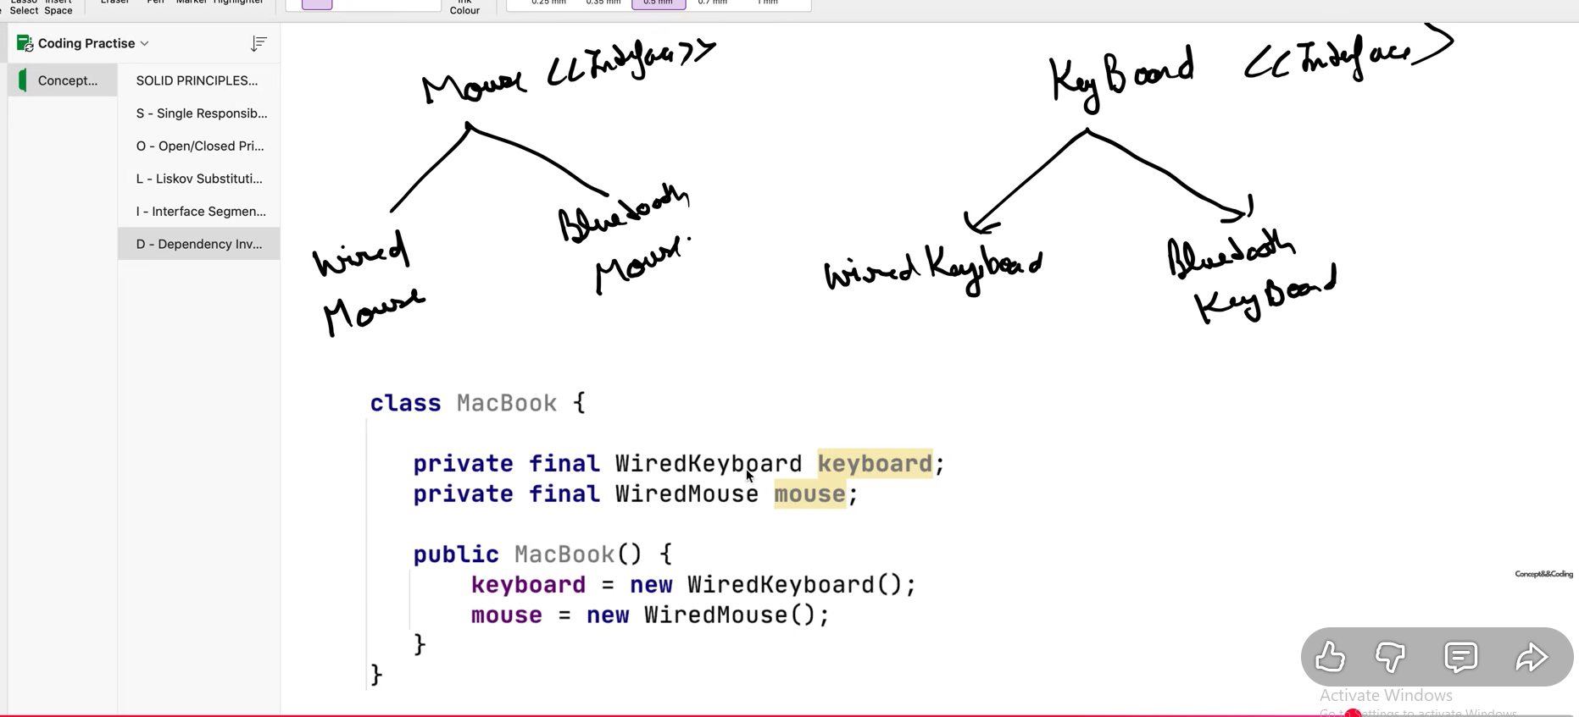
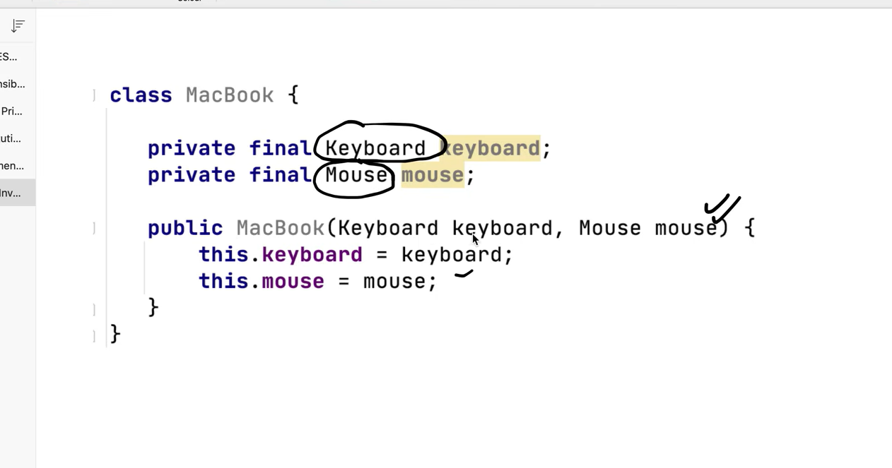
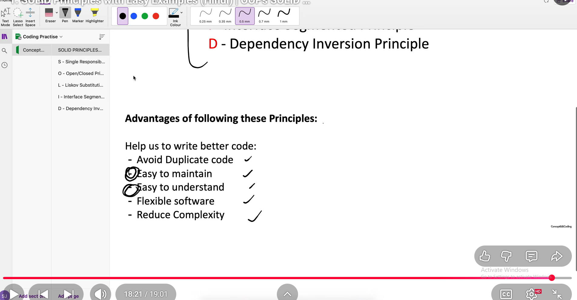

20Apr – day -3 (liskov substion principle with solution)
If you have one parent and another child class. You should be able to swap the object without breaking the code.
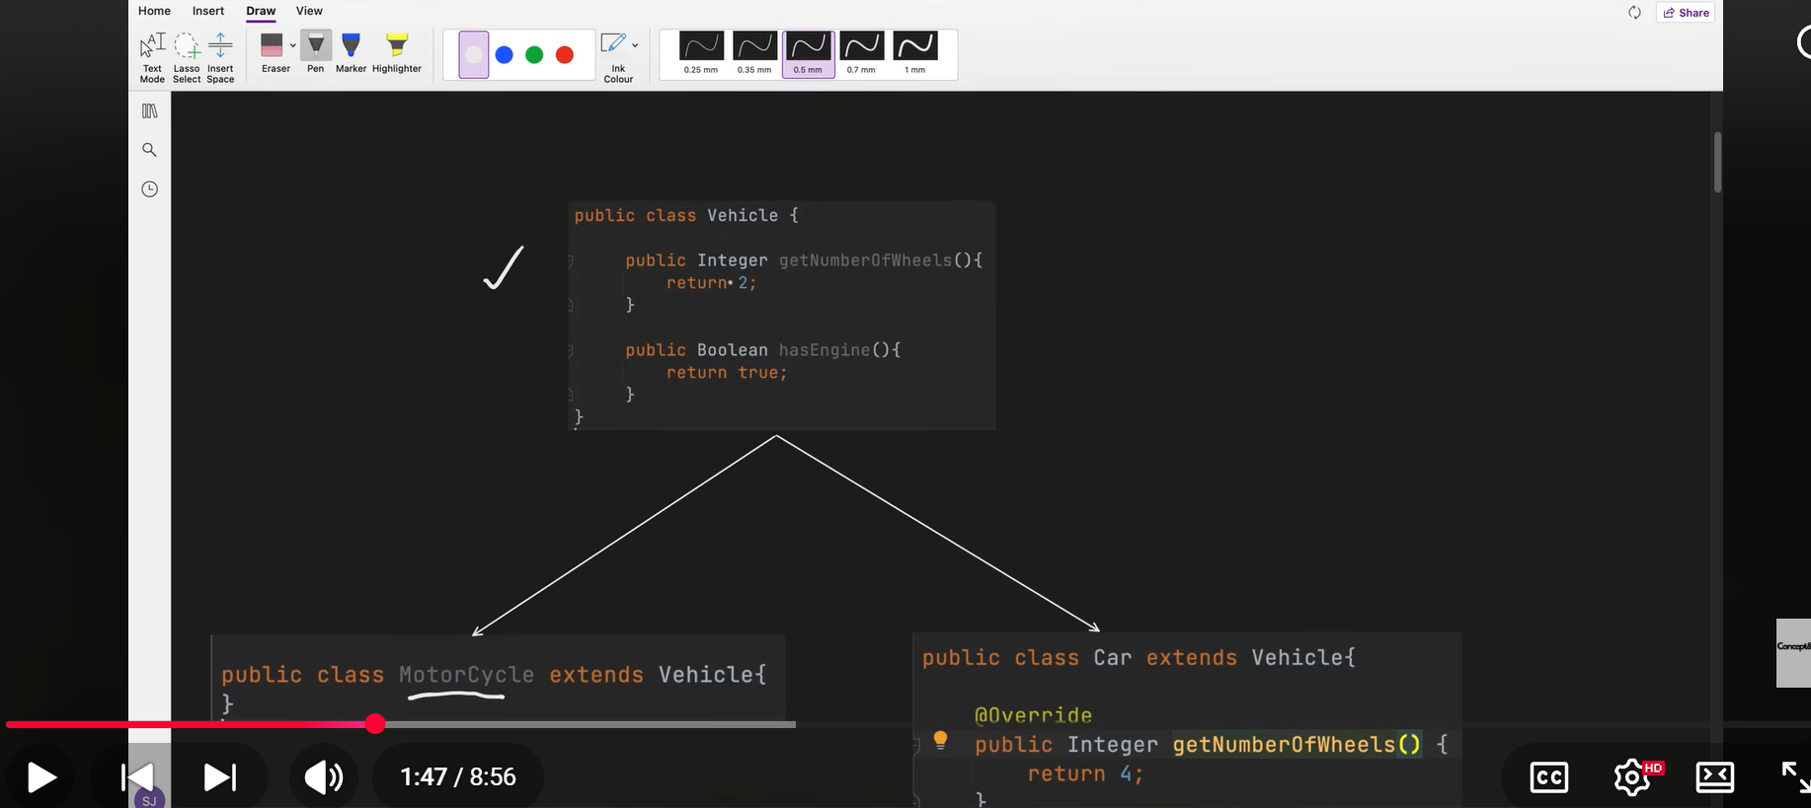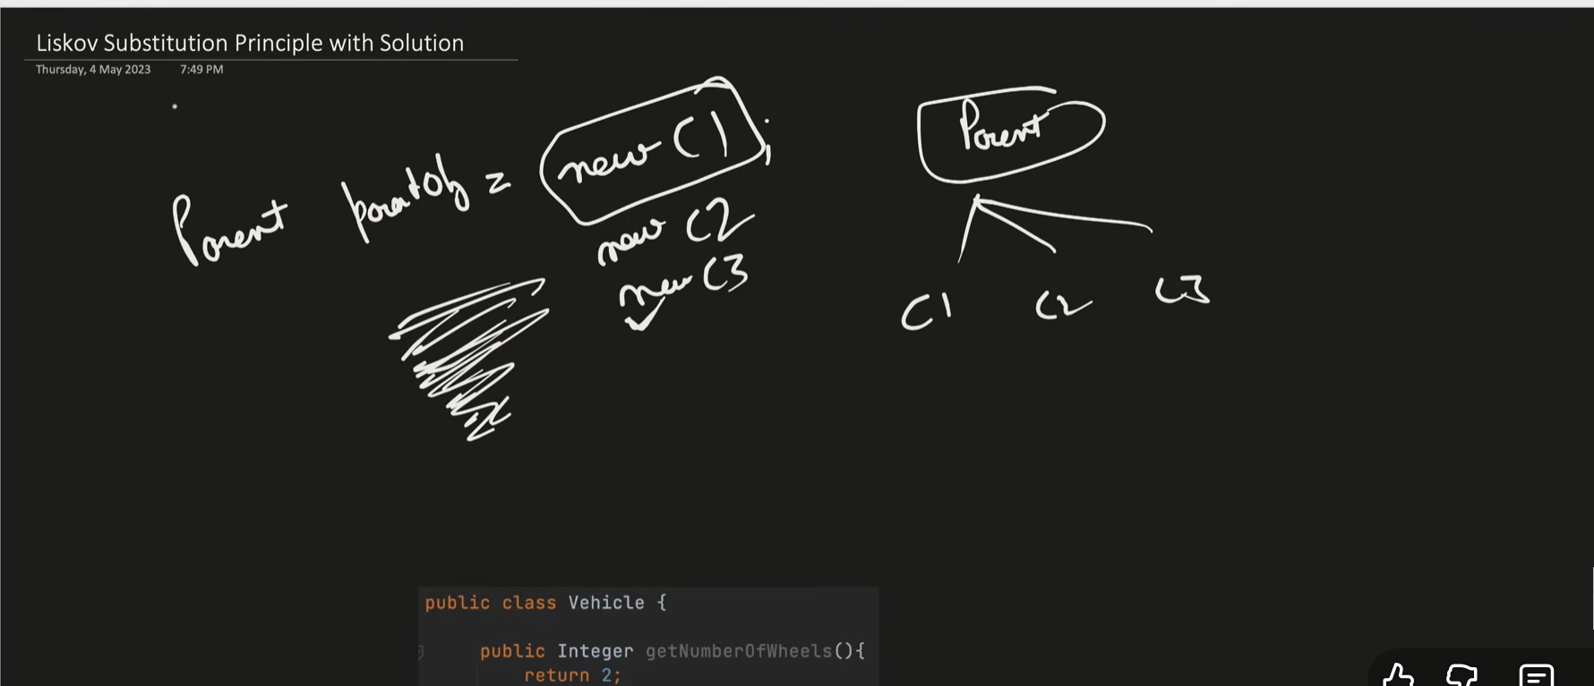
as much as I will inherit some classes it must not be break.
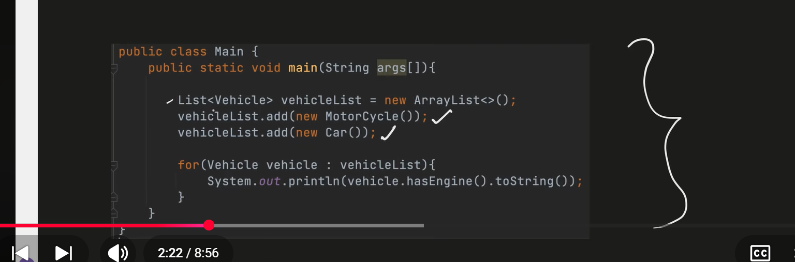
above will work
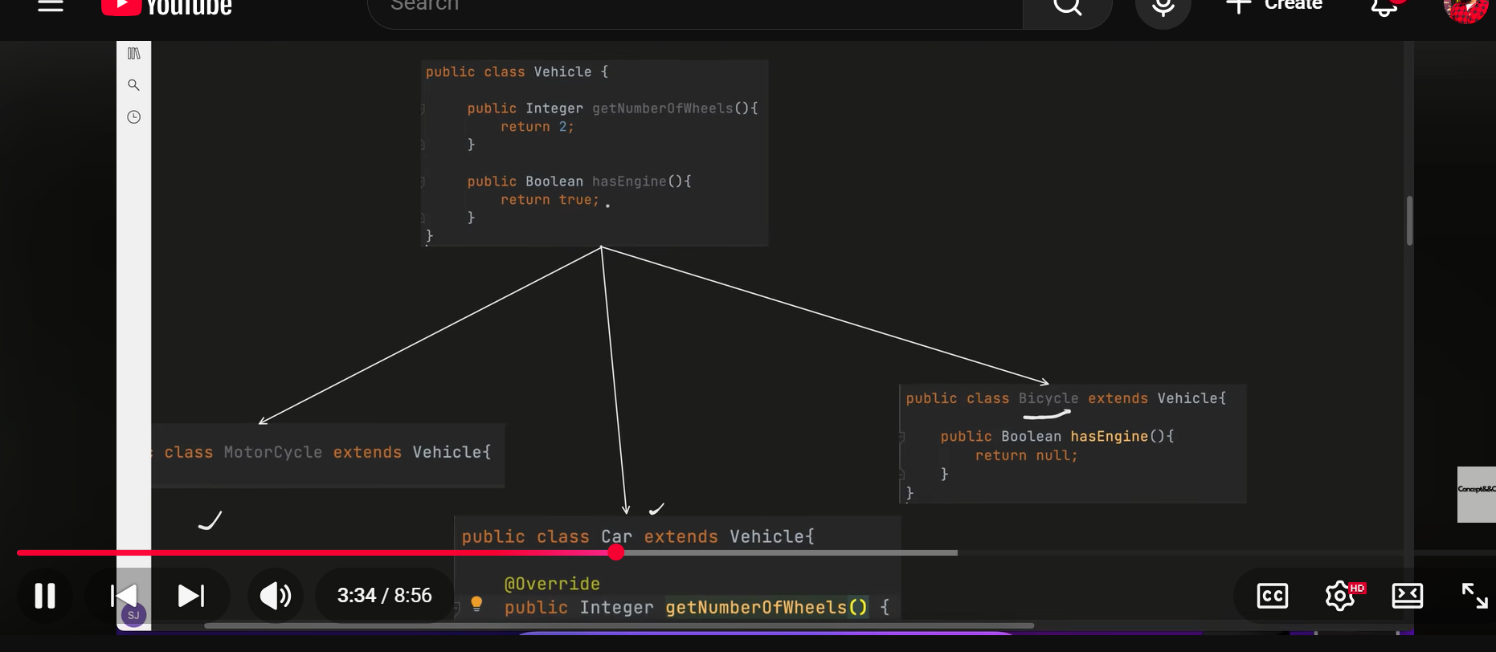
now the bicycle has engine will be null that will cause us the null pointer exception, in this way it will break. Because in the client code we have called the hasengine method that will cause null pointer exception. Let suppose there are hundred of conditions accessing this class then we have to done a lot of conditional code for this that increase the boilerplate code.

Solution considered the generic methods in the super class and the critical methods inside the child classes
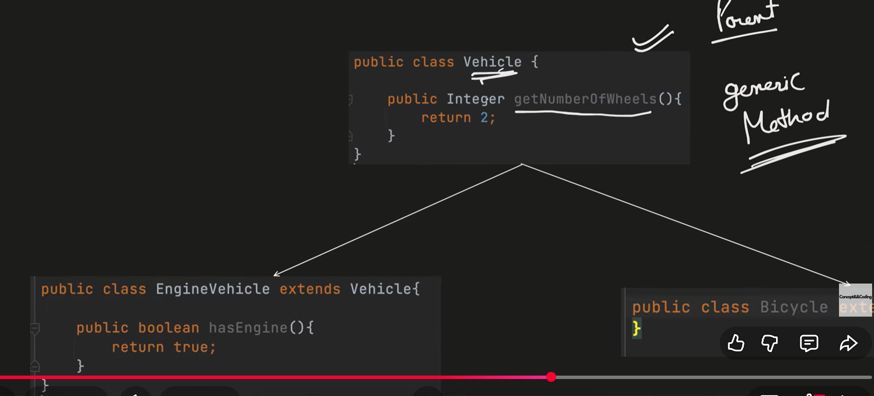
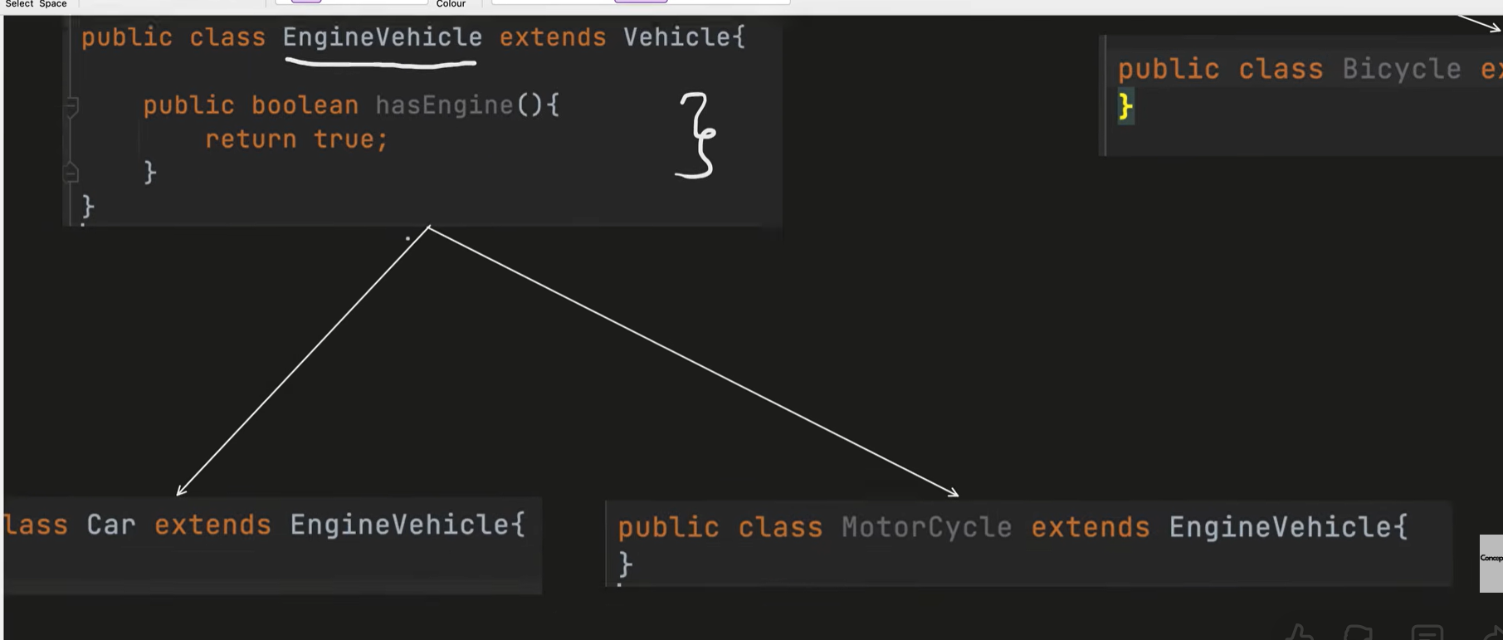
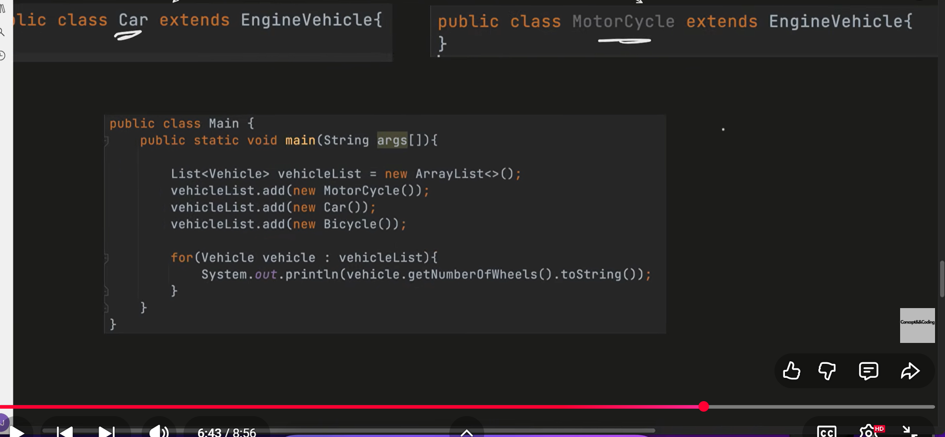
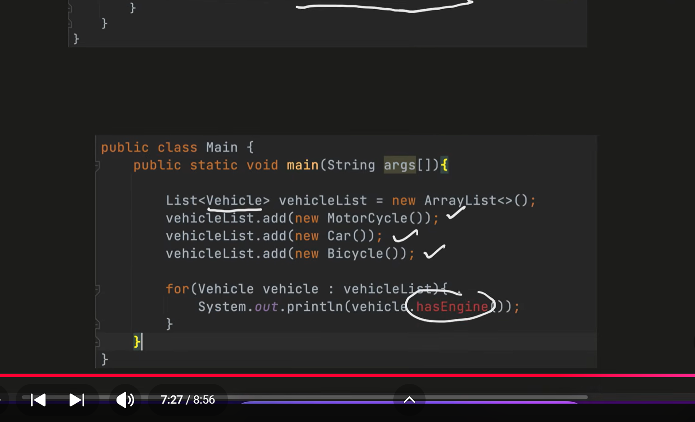
we won’t be able to call hasEngine in this scenario.
Strategy Design Pattern

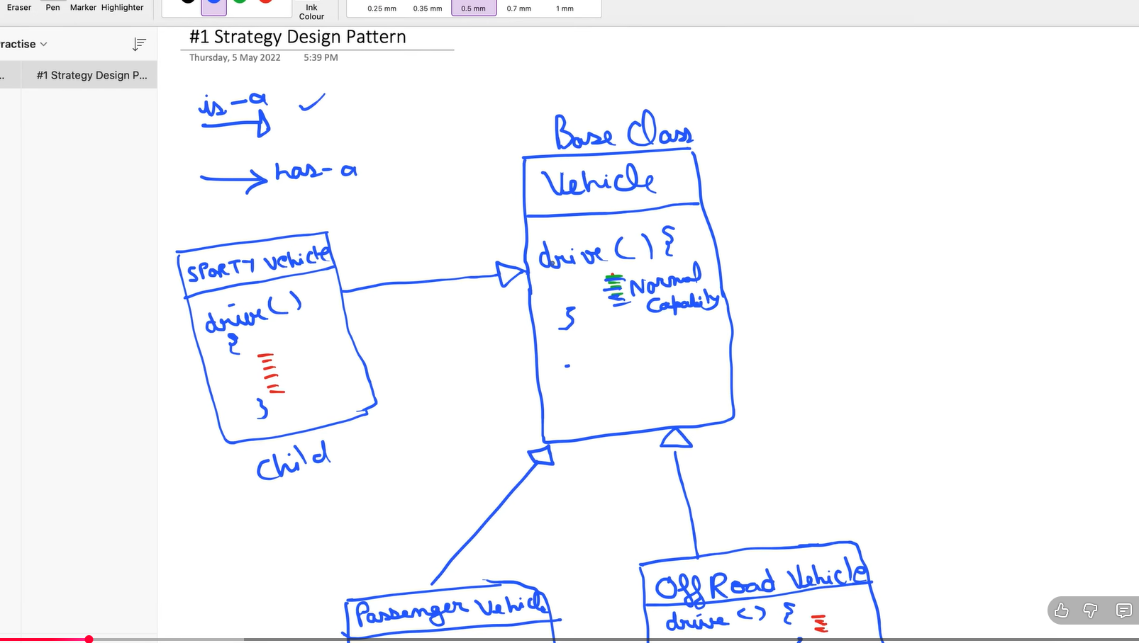

HLD (D1)
Types of Network Protocols
Last Updated : 28 Apr, 2026

Network protocol is a collection of rules that governs how data is transmitted, received, and interpreted between devices on a network, regardless of their internal structure or design.
- Defines what, how, and when data is communicated.
- Enables communication between heterogeneous devices.
- Ensures reliable and standardized data exchange.
- Prevents data loss, duplication, and misinterpretation.
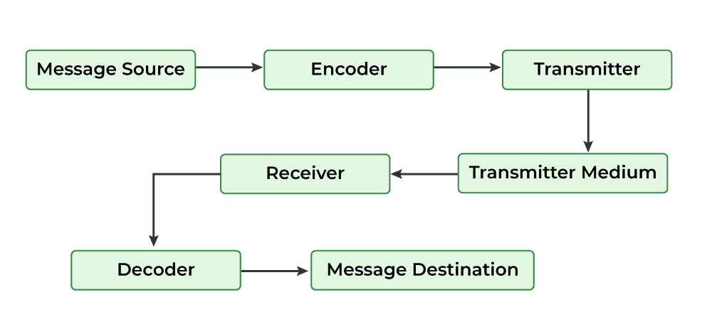Communication process showing how data is encoded, transmitted, and decoded using network protocols.

Working of Network Protocols
Network protocols work by dividing communication tasks into layers, where each layer performs a specific function to ensure successful data transmission.
- Communication is based on the OSI model, which consists of 7 layers.
- Each OSI layer uses specific protocols to perform its task.
- Data moves layer by layer from sender to receiver.
- Example: Internet Protocol (IP) operates at the Network Layer and handles routing using source and destination addresses.
- Layered communication improves reliability, scalability, and troubleshooting.

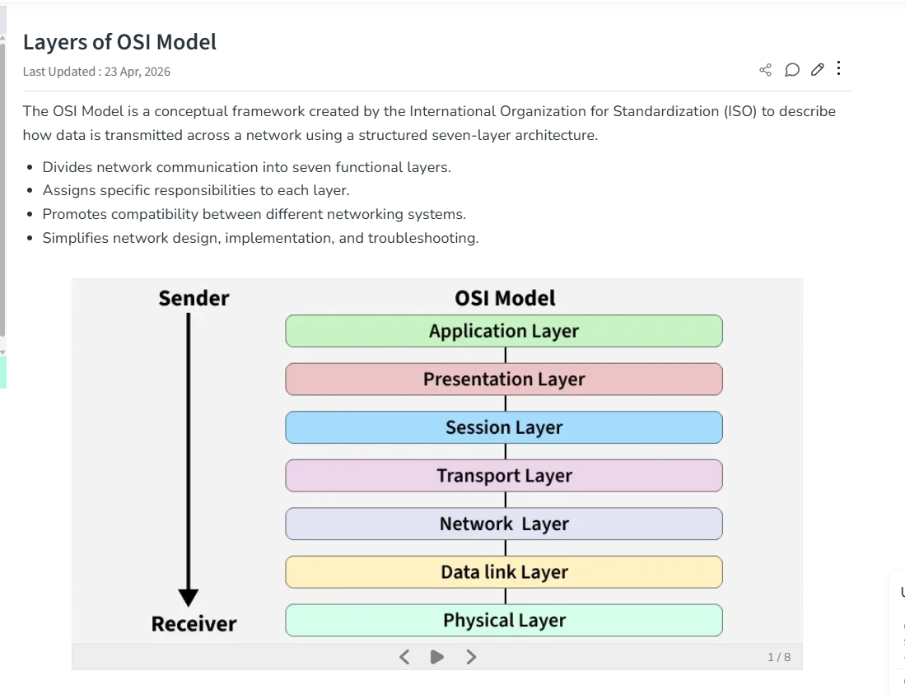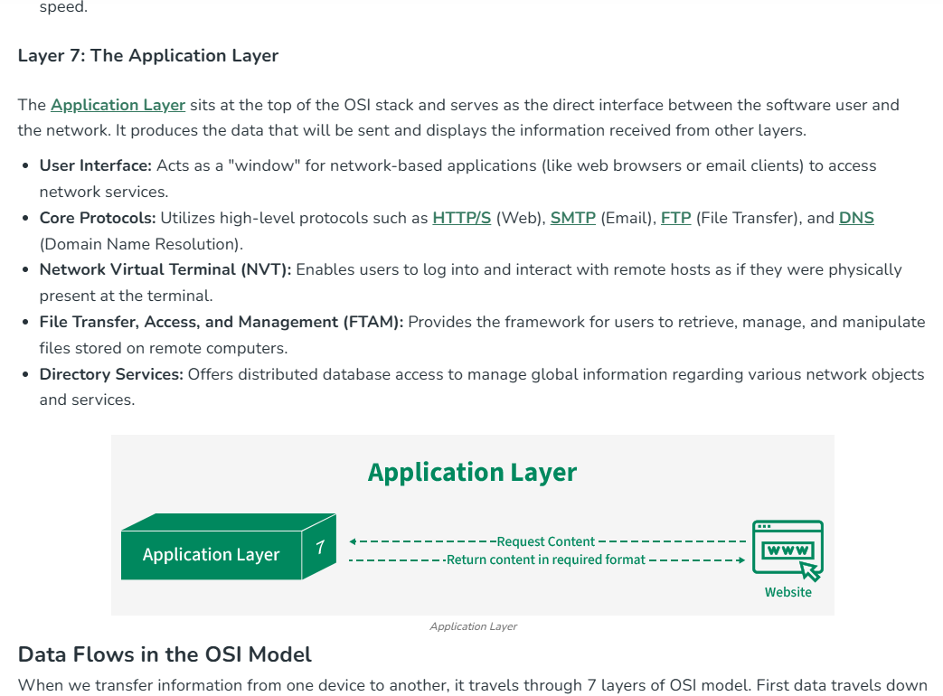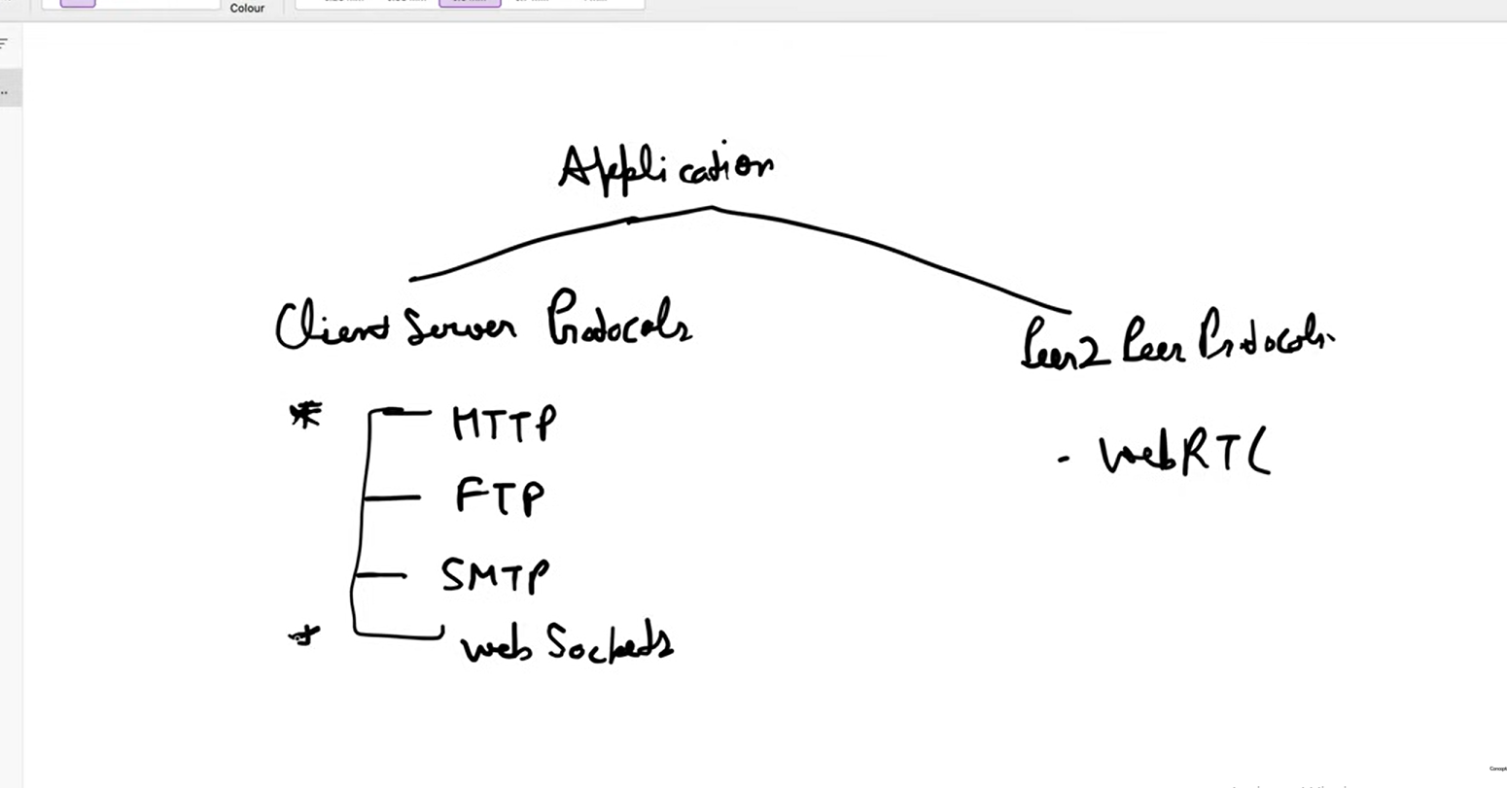

Client-Server Protocols
These follow a request–response model where a client sends a request and a server responds.
- HTTP (HyperText Transfer Protocol)
The foundation of the web. It’s used for transferring web pages and resources (like HTML, images). Stateless and typically runs over TCP.
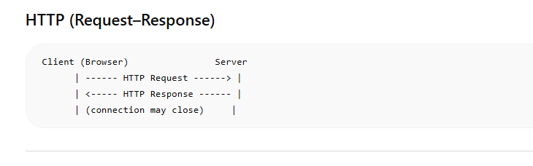
- FTP (File Transfer Protocol)
Used to transfer files between a client and a server. Supports uploading and downloading, but is less secure unless combined with encryption (e.g., FTPS/SFTP).
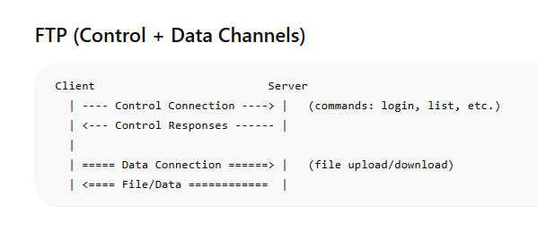

- SMTP (Simple Mail Transfer Protocol)
Used for sending emails between servers and from clients to mail servers. Works alongside other protocols (like IMAP/POP3) for retrieving emails.
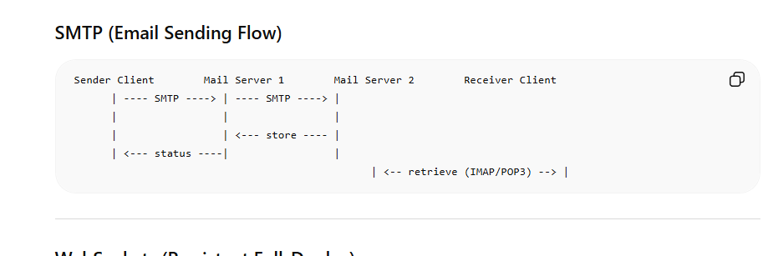
- WebSockets
Enables persistent, full-duplex communication between client and server over a single connection. Useful for real-time apps like chats, gaming, and live updates.
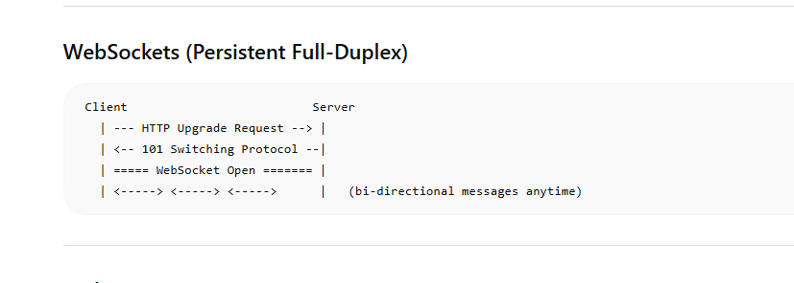

Peer-to-Peer Protocol
- WebRTC (Web Real-Time Communication)
Allows direct peer-to-peer communication between browsers or devices. Supports audio, video, and data sharing without needing an intermediate server (after initial setup). Common in video calls and live streaming.
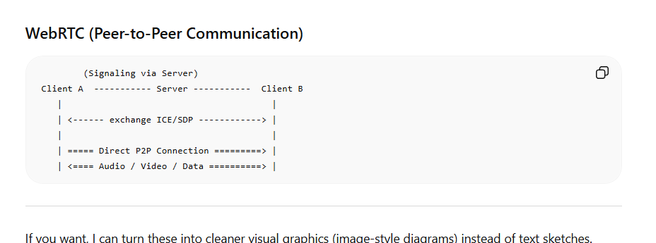

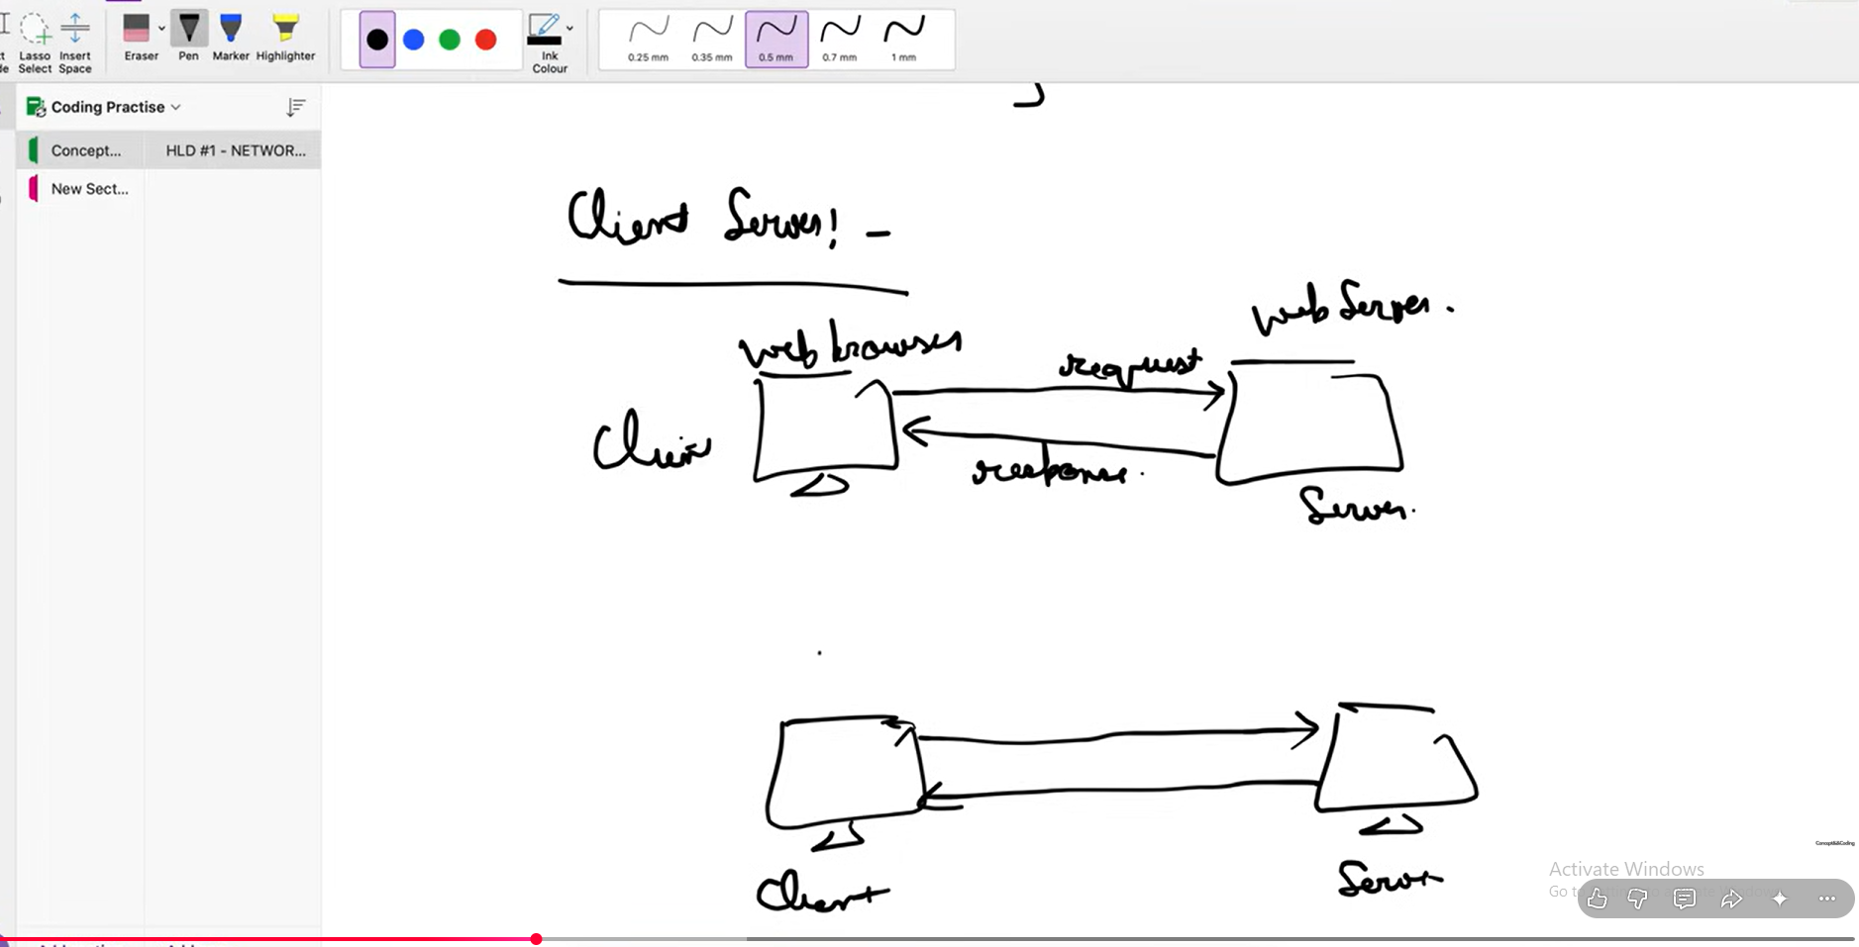
(websocket) is bi-directional communication between client and server and in normal connect between (client and server) client can talk to server but server cannot talk to client but this is possible in the case of websocket communication that’s why its not a peer-to-peer connection. 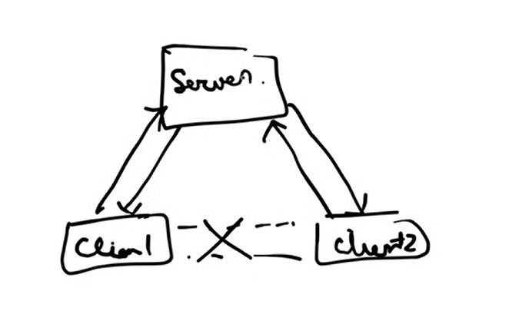
In the case of websocket
In the context of SMTP the
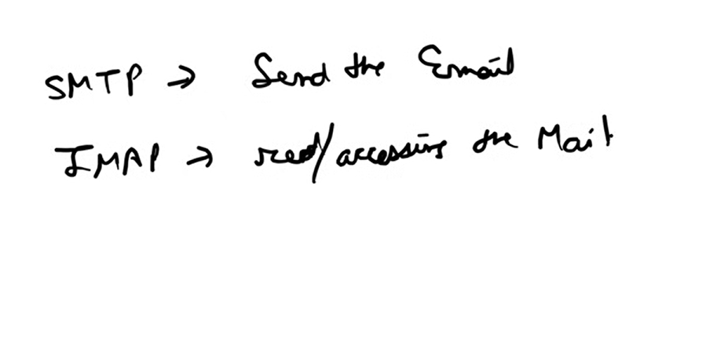
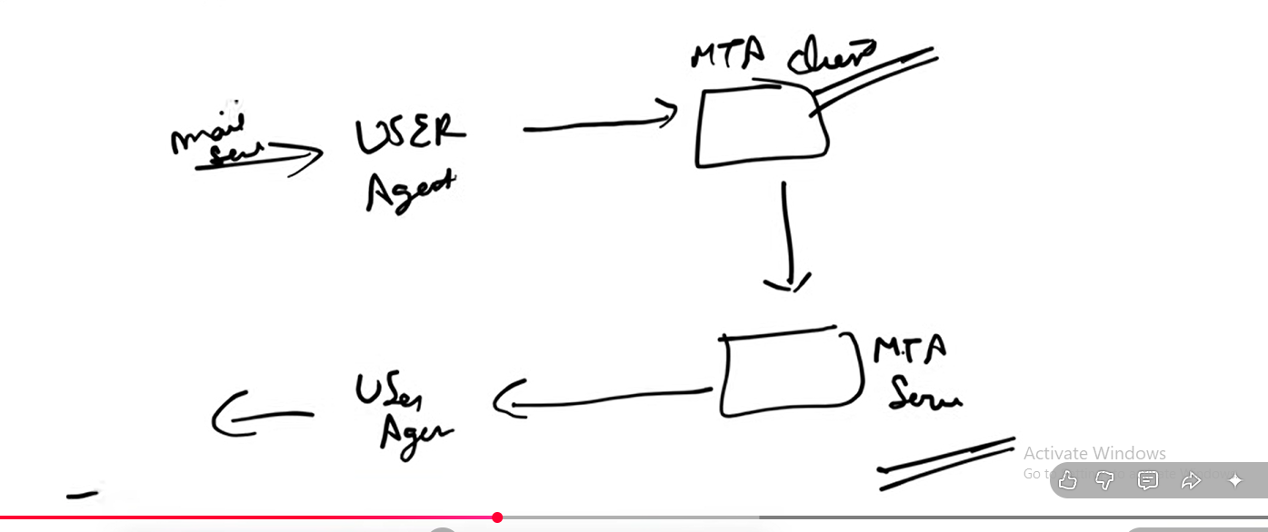
Layer 4: The Transport Layer
The Transport Layer ensures the end-to-end delivery of entire messages. It acts as a liaison, providing services to the Application layer while utilizing the infrastructure of the Network layer to ensure data reaches the correct application on the destination host.
- Data Unit: Data is broken down into Segments.
- Service Point Addressing: Uses Port Numbers (e.g., Port 80 for web traffic) to ensure data is delivered to the specific process or application intended, not just the device.
- Segmentation & Reassembly: Splits large messages into smaller segments for transmission and reassembles them in the correct order at the destination.
- Protocols: Common protocols include TCP (reliable), UDP (fast).
- Connection-Oriented (TCP): Requires a "handshake" to establish a connection; ensures reliability via error checking and acknowledgements.
- Connectionless (UDP): Sends data immediately without a formal connection; faster but offers no guarantee of delivery.
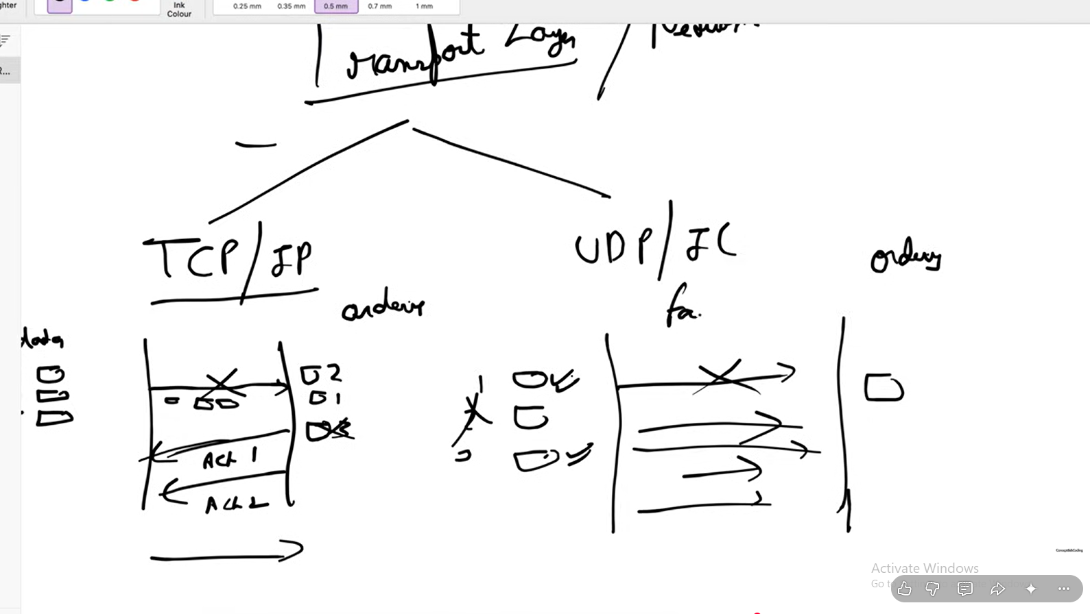

Transport Layer (Overview)
The transport layer is responsible for end-to-end communication between applications. It ensures data is delivered correctly (or quickly, depending on protocol choice).
There are two main protocols:
- TCP (Transmission Control Protocol) → Reliable, ordered
- UDP (User Datagram Protocol) → Fast, unordered

1. TCP (Reliable, Ordered Communication)

🔹 Key Features
- Connection-oriented (3-way handshake)
- Guarantees delivery 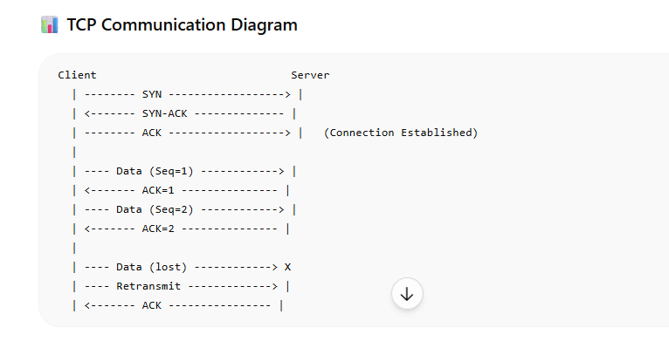
- Maintains order

Uses acknowledgments (ACKs) and retransmissions
💡 Example Use Cases
- Web browsing (HTTP/HTTPS)
- File downloads
- Email (SMTP, IMAP)
👉 Example: When you open a website, TCP ensures all page elements load correctly and in order.

2. UDP (Fast, Unreliable Communication)

🔹 Key Features
- Connectionless (no handshake)
- No guarantee of delivery
- No ordering
- Very low latency
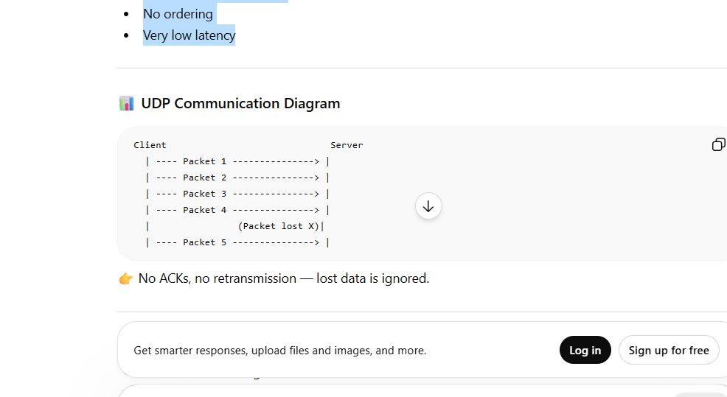
👉 No ACKs, no retransmission — lost data is ignored.

💡 Example Use Cases
- Live video streaming
- Online gaming
- Voice calls (VoIP)
- DNS queries
👉 Example: In a video call, it’s better to skip a lost frame than wait and cause lag.
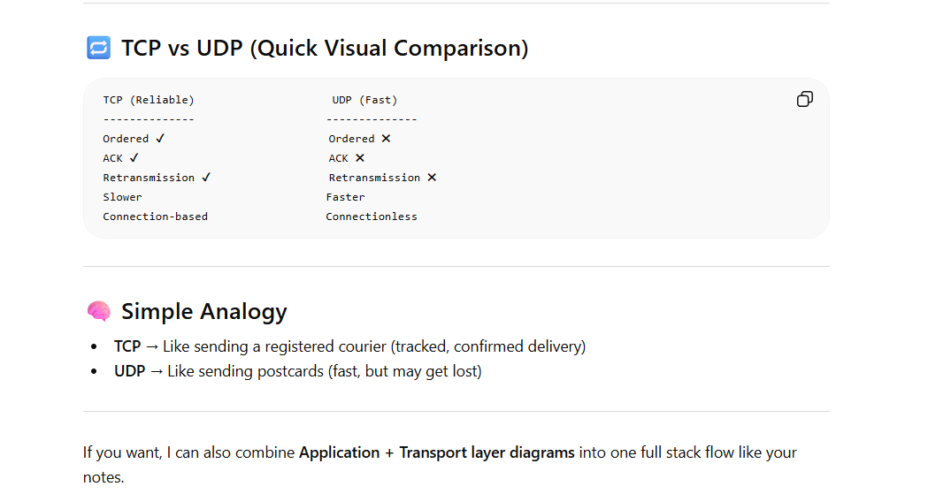

LLD – 7 May 2026

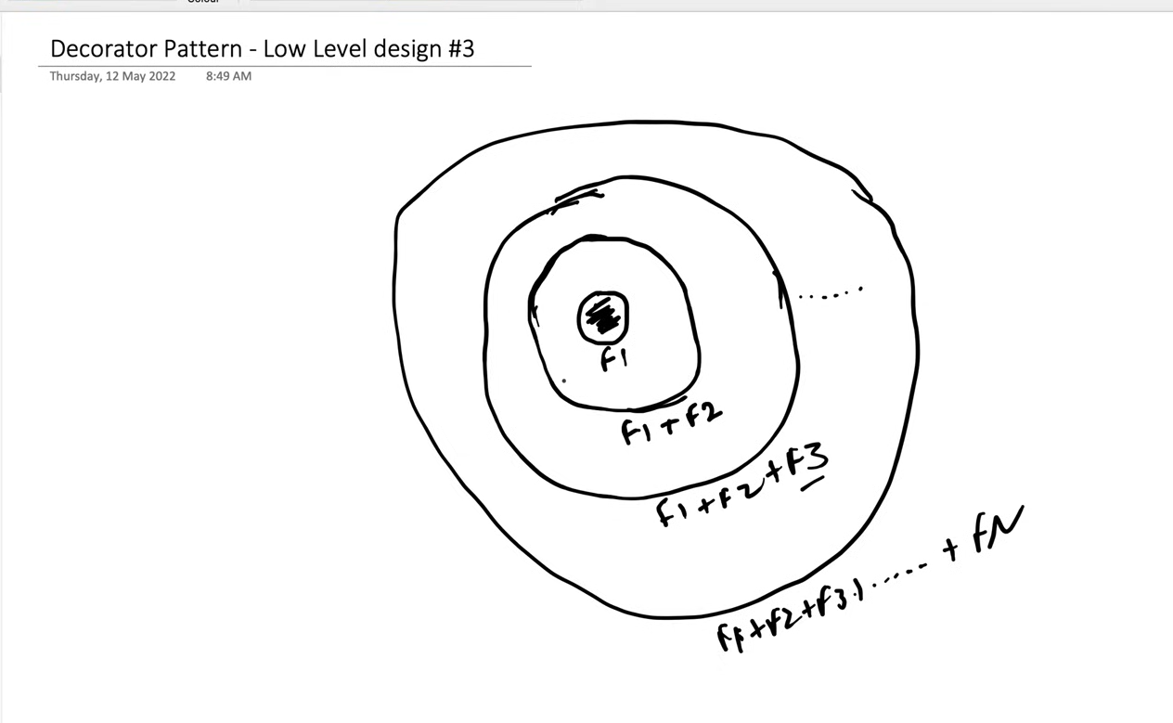
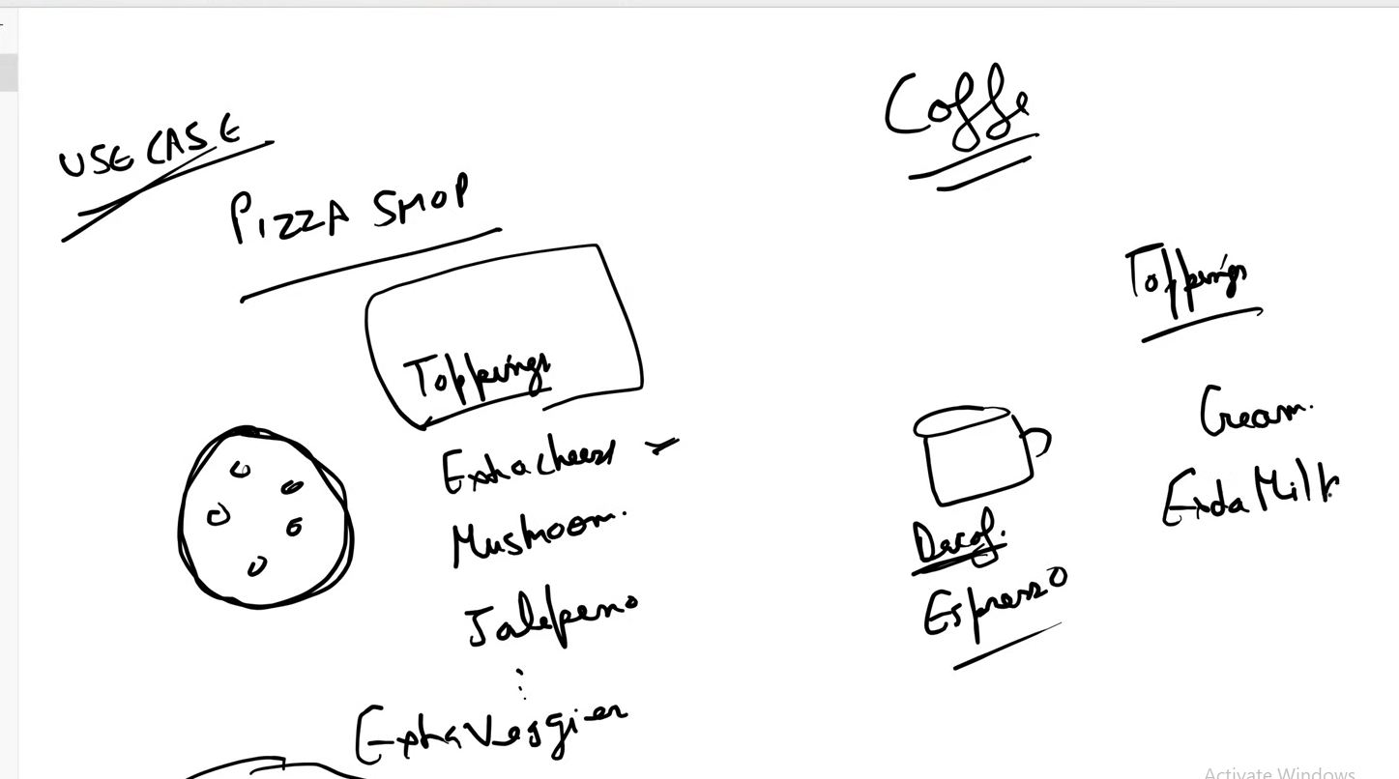
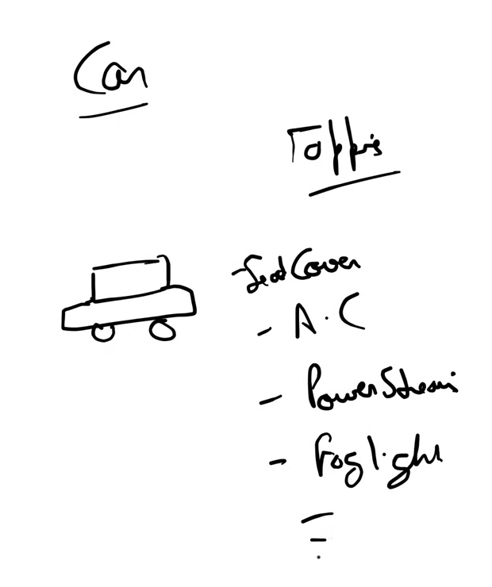
Design coffee machine:-
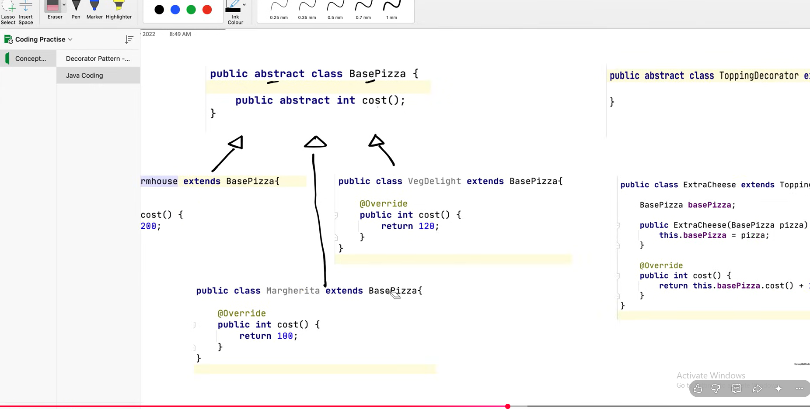
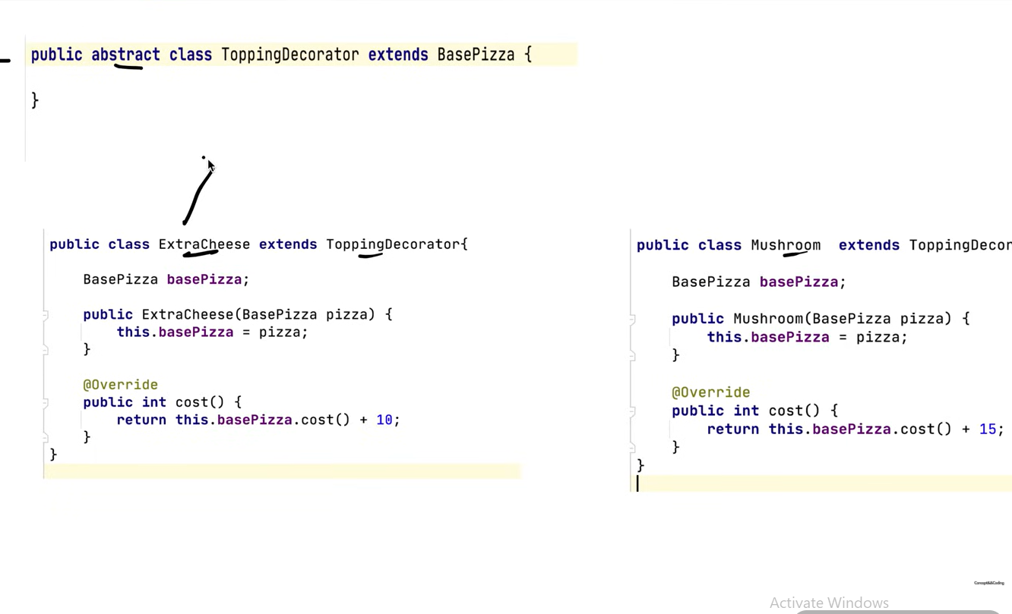
(HLD 8 May (CAP Theorm) )
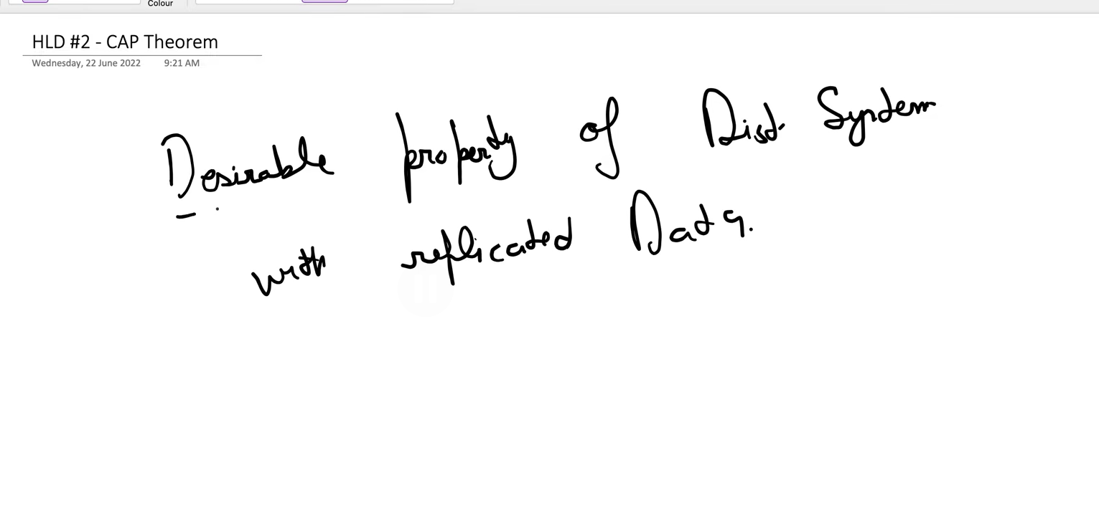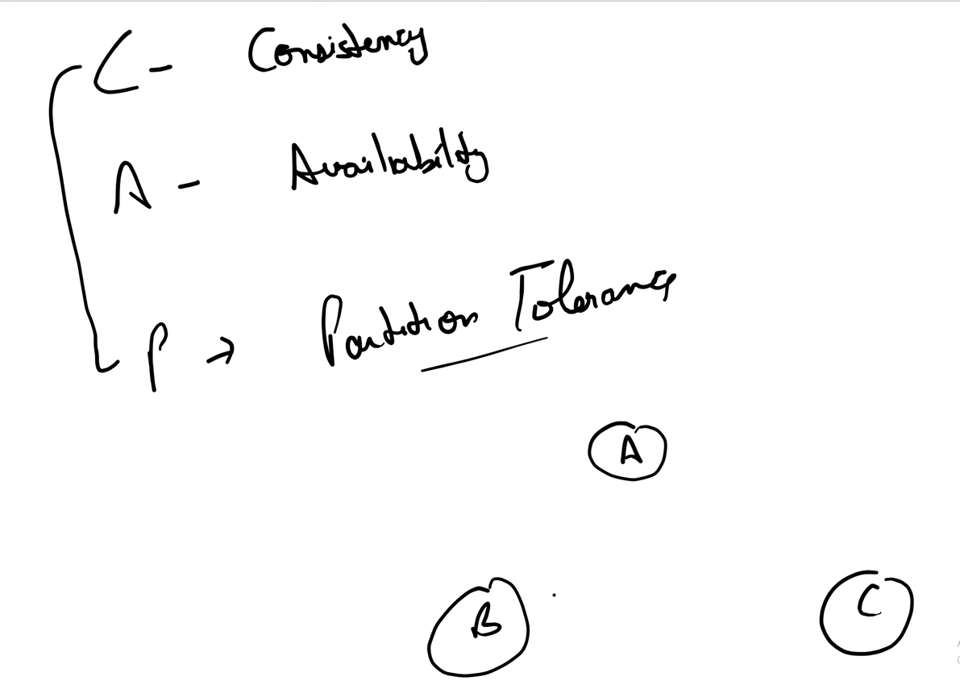
Desirable Property distributed system with replicated data.
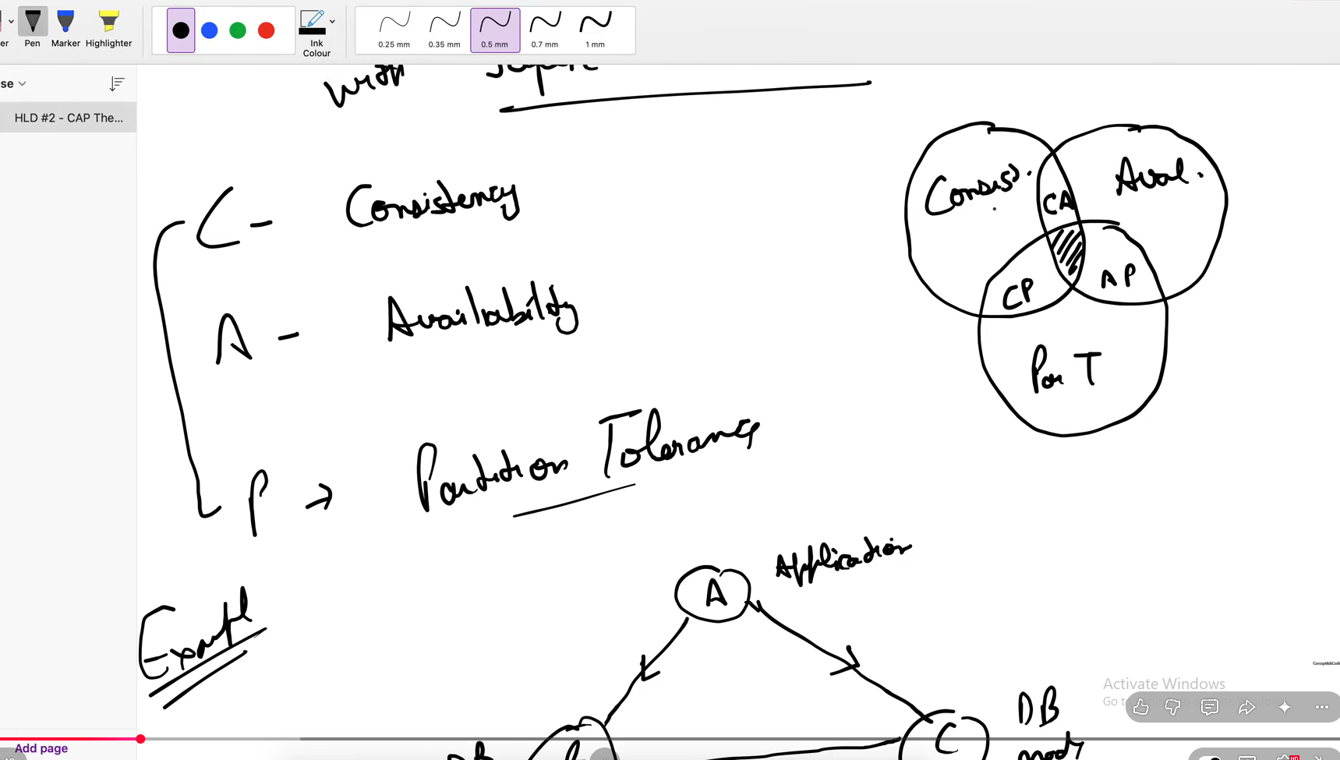
Consistency means after the successful write if a one node getting the value from other node then then it will be same.
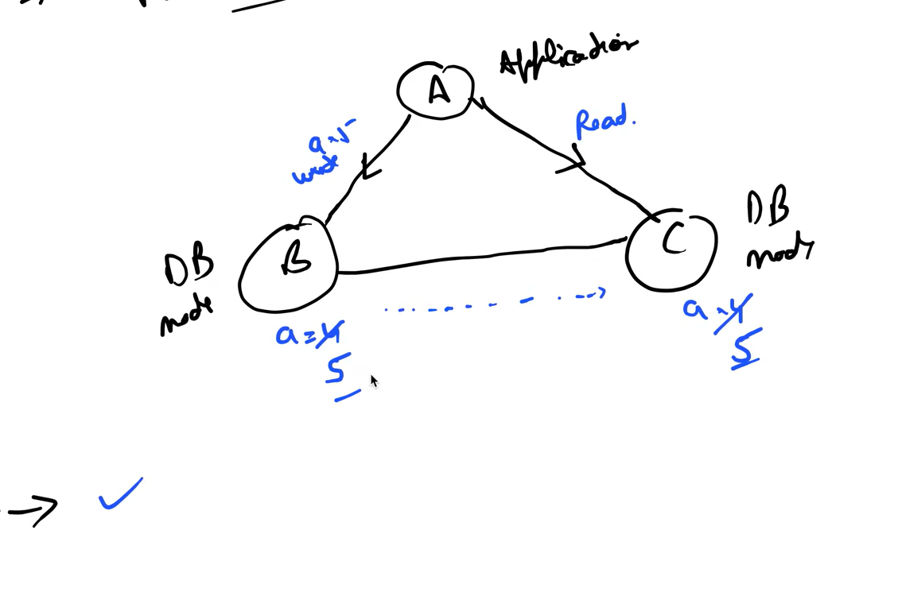
Avaliability – All nodes should respond (if data received or not )
Partition Tolerence – Lets suppose there is the communication (partition) breakage between B and C but A is able to query then this condition is known as partition tolerence.
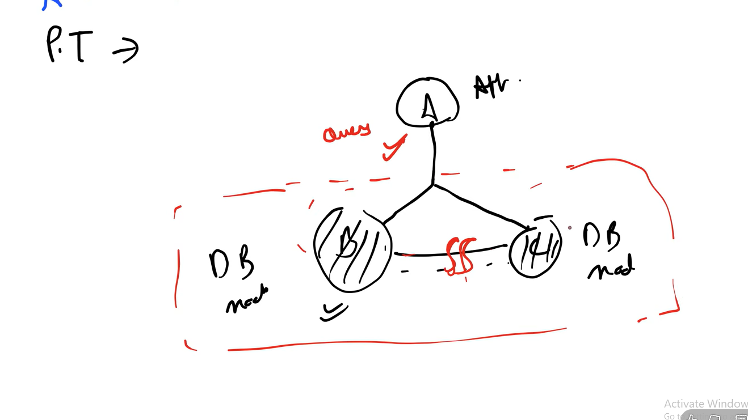

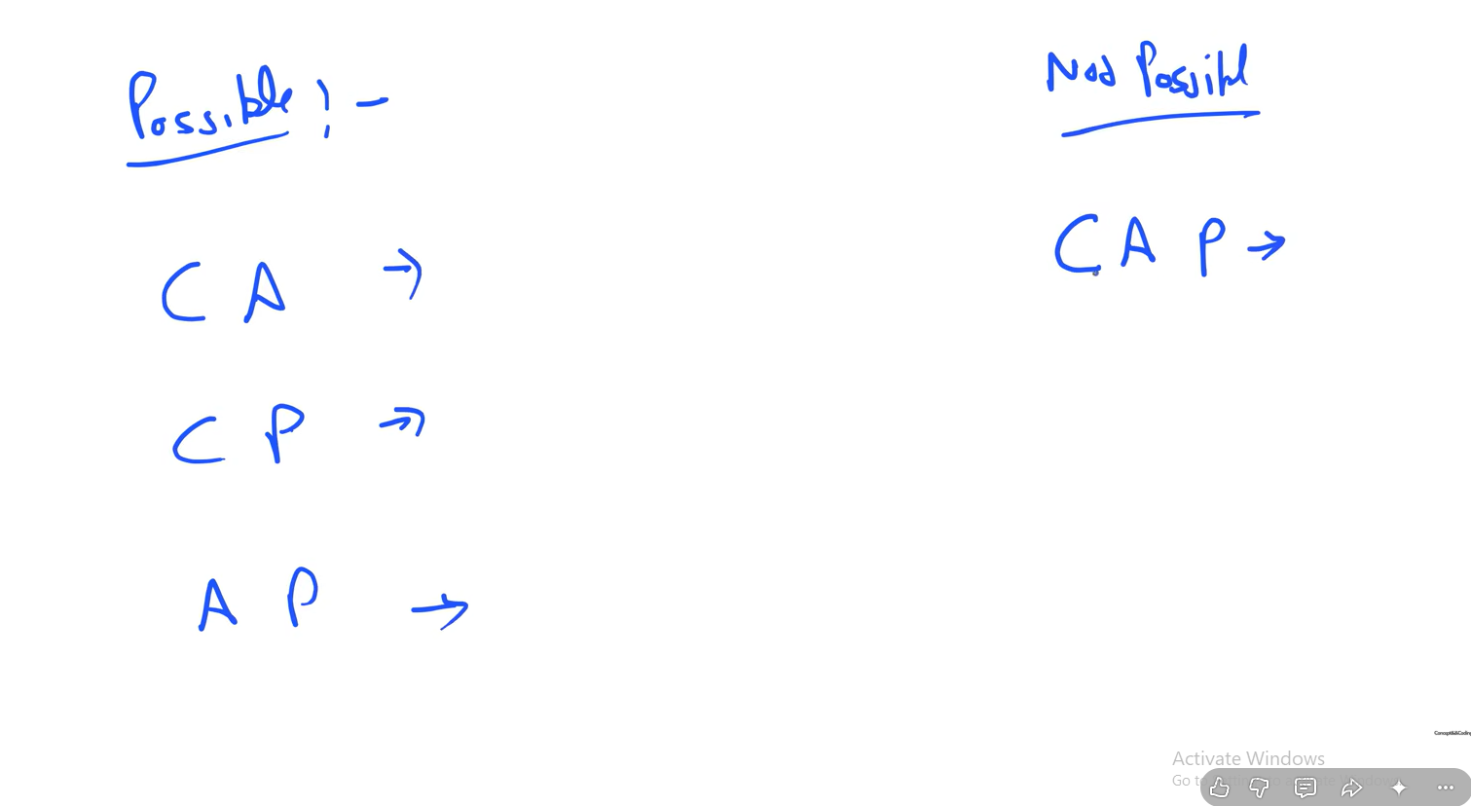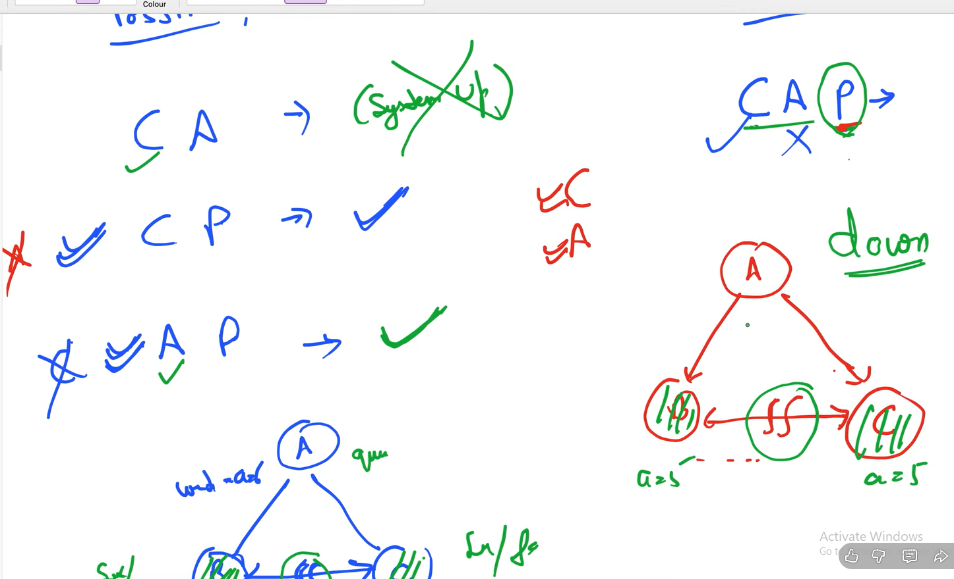

Possible Scenarios –

  - Consistency + Avaliability (CA) – the consistency and availability in this scenario lets suppose the value of x= 5 is updated at node A then its updating B and C also and all of the nodes are responding while received or not we have removed the partition tolrenence
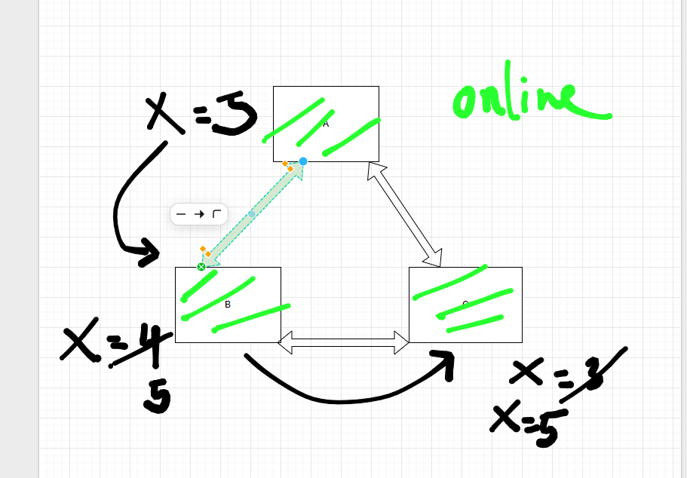

Strangler design pattern - The Strangler Fig Pattern, often referred to as the Strangler Pattern, is an architectural strategy used to incrementally migrate a legacy system—such as a monolithic application—to a modern architecture, like microservices, without a risky "big bang" rewrite.

Way of taking monolithic to microservices.
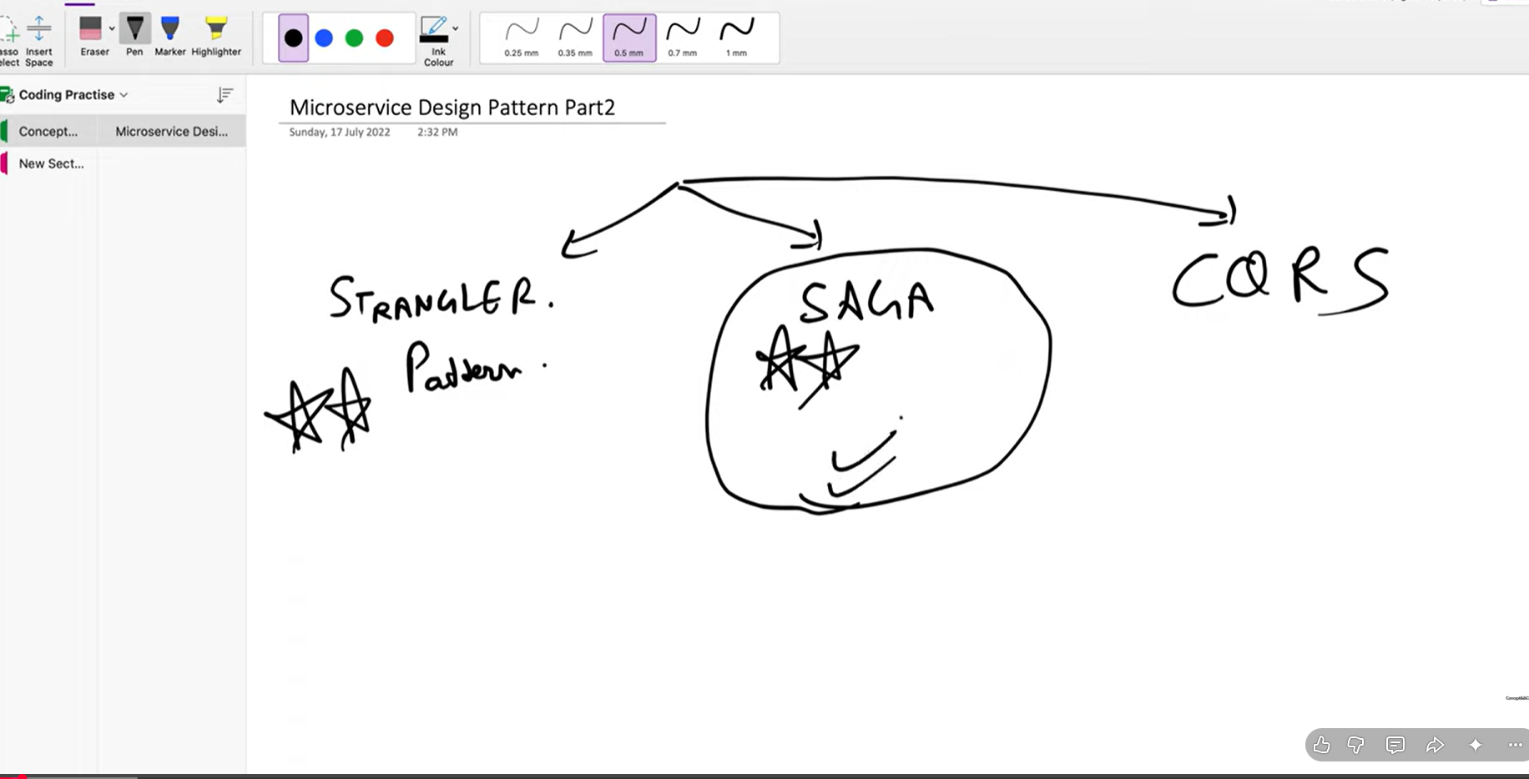

Key Implementation Components
- Legacy System: The existing monolithic application containing the original business logic.
- New System: The modern application or microservices developed in parallel.
- Facade/Router: A critical component (often a proxy or API gateway) that intercepts incoming requests. It determines whether to route traffic to the legacy system or the new system based on specific criteria, such as feature flags, user IDs, or endpoint availability.
- Incremental Migration: Functionality is migrated piece by piece. As the new system takes over specific features, the facade redirects those requests accordingly, eventually handling all traffic.

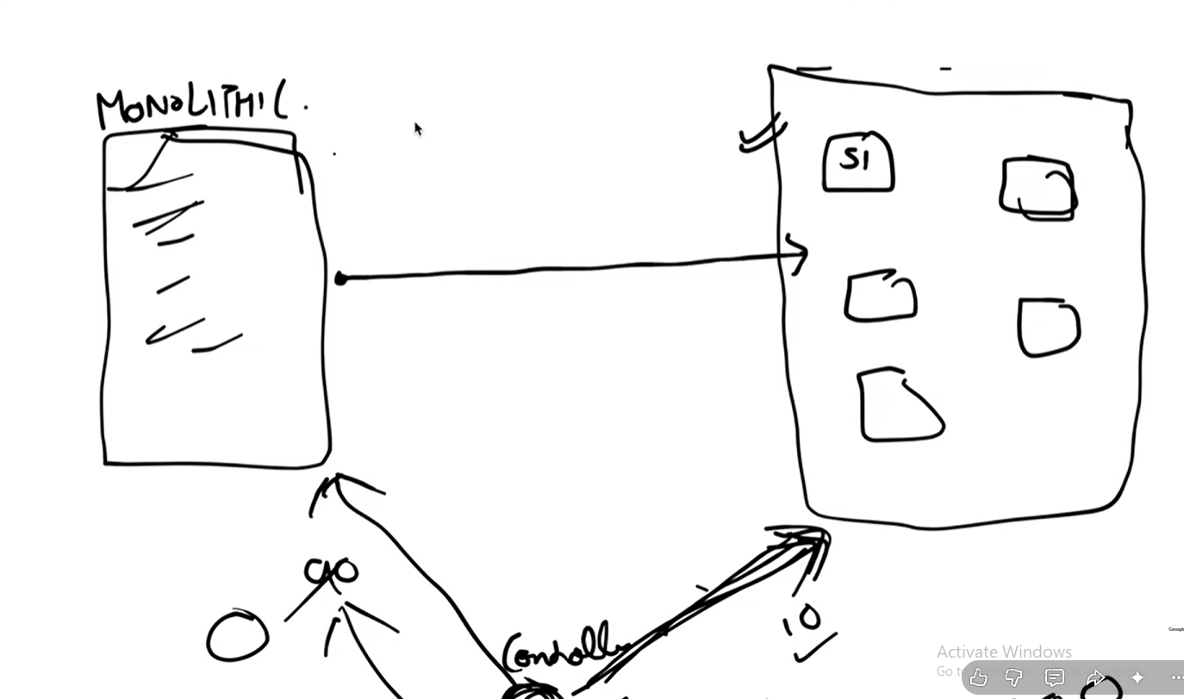
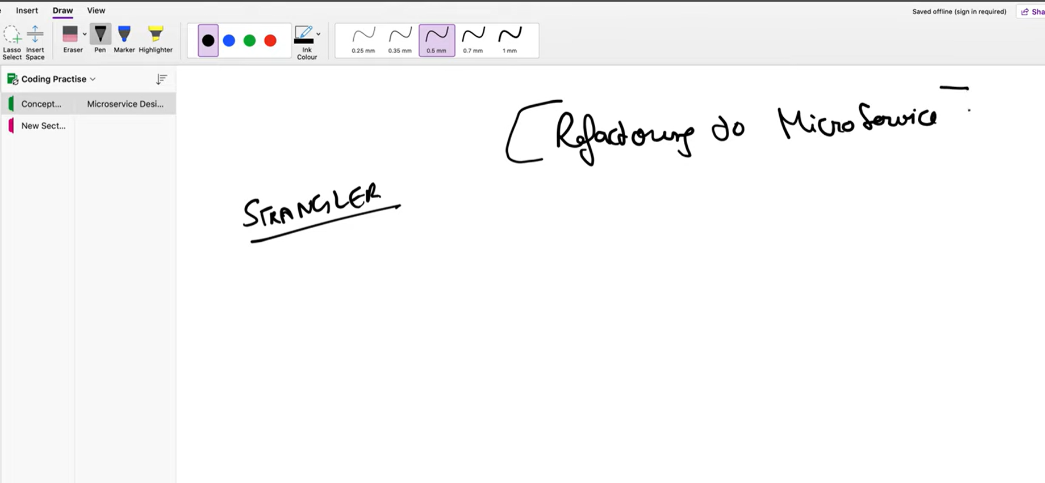
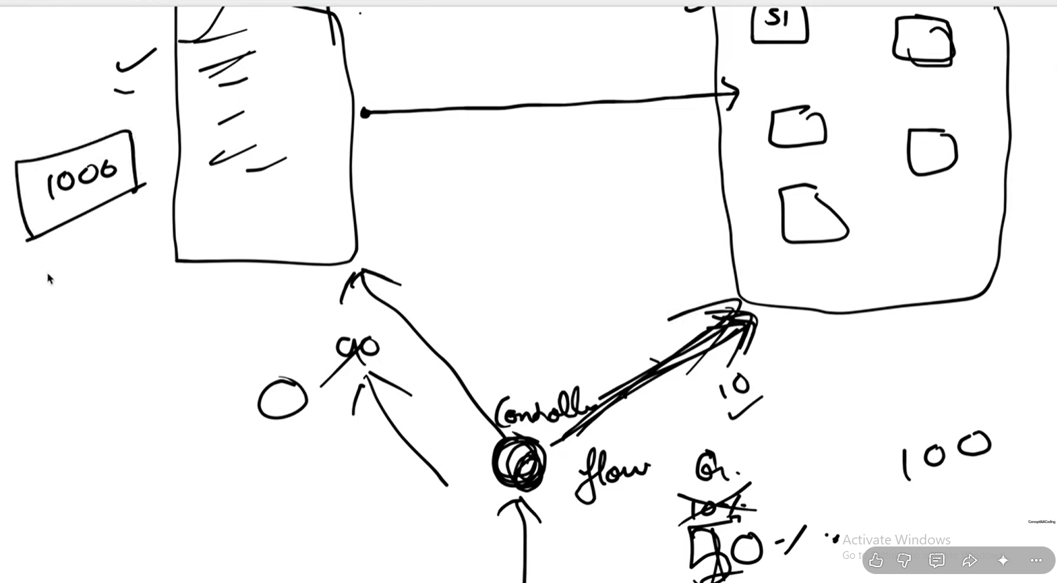
Data Base Management in microservices
1. Database for each individual service – every microservice have separate database in this case.

  - Shared Database – every microservice is connected with a common database that’s why its called shared database.
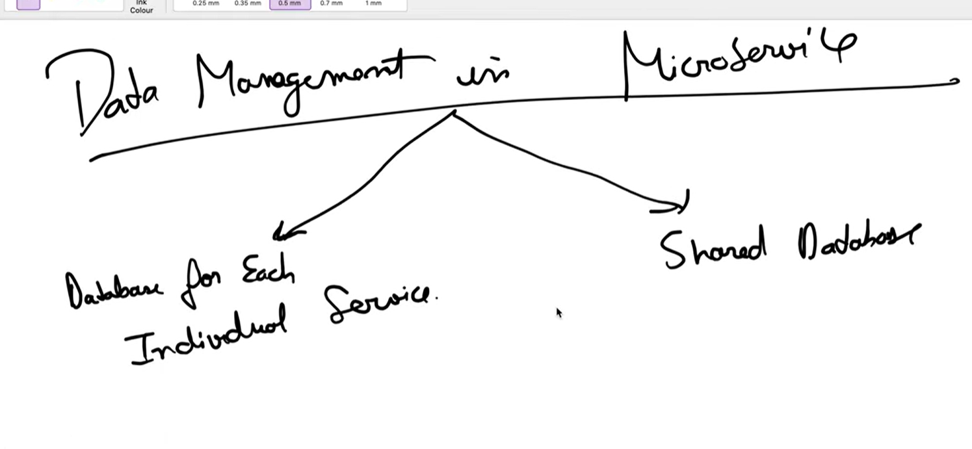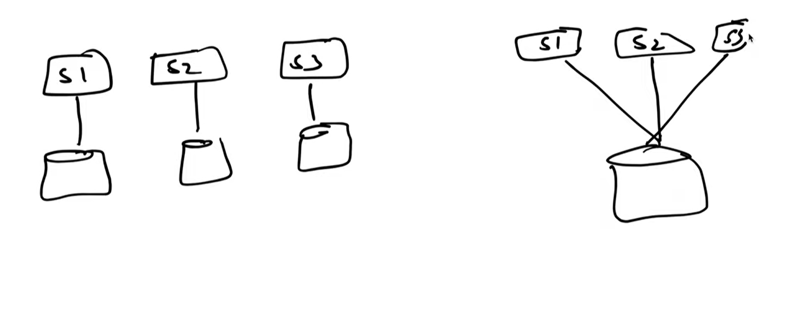
  - 30 june ( 0 - million user) (HLD)
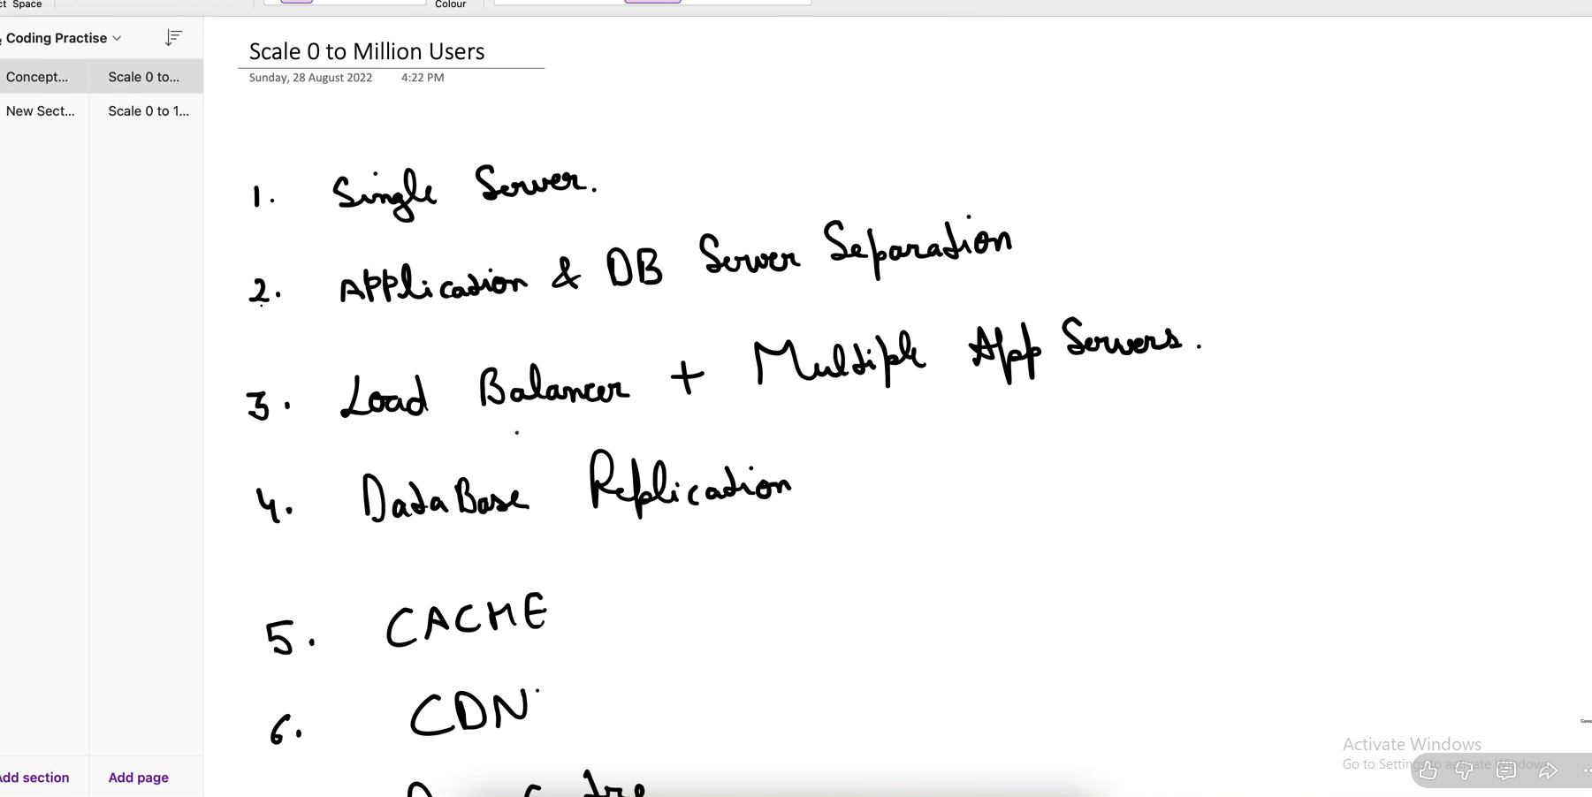
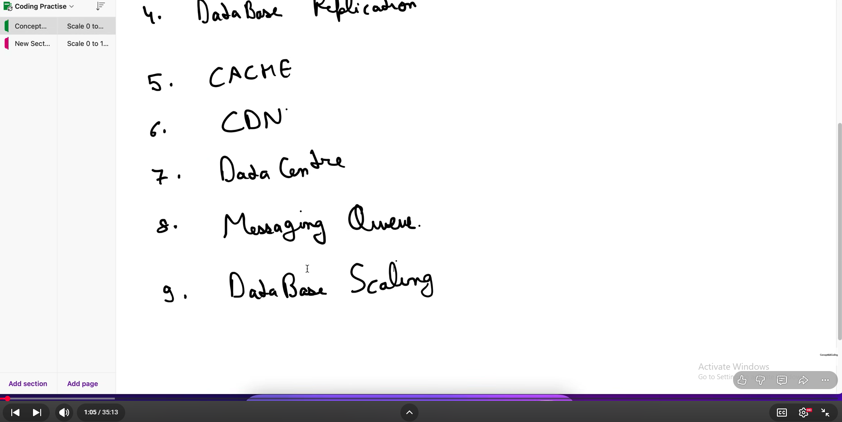
1. single server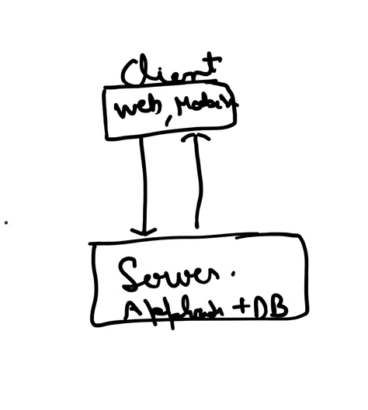
make client to server interaction

2.Application & DB server separation
For breaking the dependencies for each
Make them separate
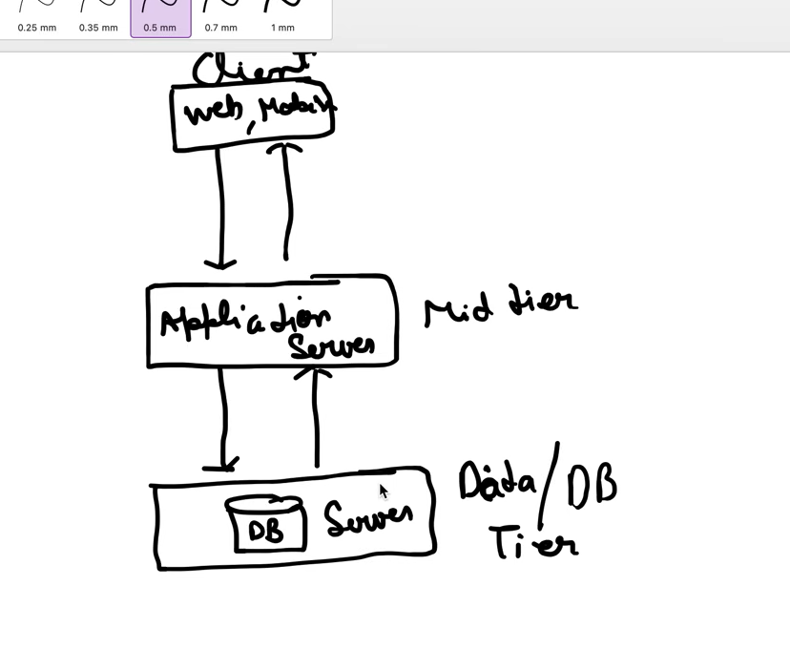
3. Add Load Balancer and Multiple App Servers at mid tier
load balancer is for manging the load and distributing over different app instances
also its add security to the app and client it shares the private ips with app instances for security.
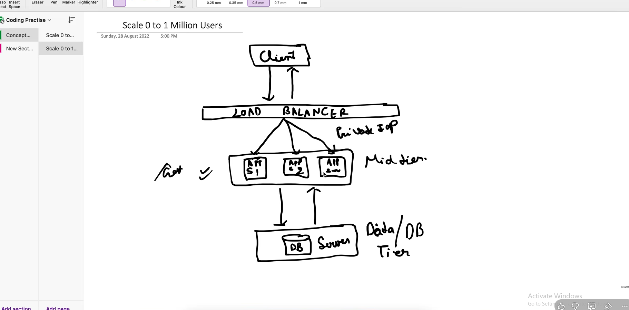
  - Database Replication – we have to make one master and one slave database for database replication all the read operations are performed on the slave db and the right operations will be performed on master db.
If master goes down the slave db will take place of the master.

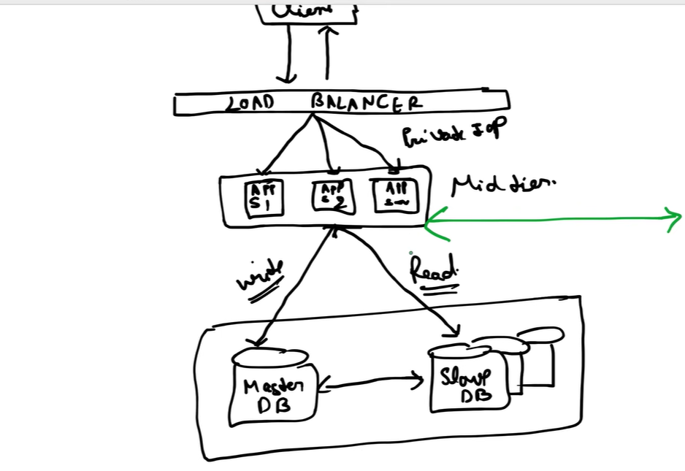

Data Replication in DBMS
Last Updated : 18 Apr, 2026

Data Replication in DBMS refers to the process of storing copies of the same data at multiple sites or nodes within a distributed database system. The main purpose of replication is to improve data availability, reliability, performance, and fault tolerance. In a distributed database environment, data replication ensures that:
- Users can access relevant data locally,
- The system remains operational even if some sites fail.
- The workload is balanced across servers.
Note: It involves copying data from one database (known as the source or publisher) to another (known as the replica, subscriber or target) so that all users can access consistent and up-to-date information without conflicts.

Need of Data Replication
- To increase data availability in case of server failure.
- To enhance performance by allowing data to be accessed from local copies.
- Improve reliability and fault tolerance in distributed systems.
- Support load balancing, where read operations are distributed across replicas.
- To simplify disaster recovery and backup processes.

Types of Data Replication

1. Transactional Replication
Involves sending an initial full copy of the database to subscribers, followed by real-time updates as changes occur at the publisher.
- Changes are propagated in the same order as they happen, ensuring transactional consistency.
- It is ideal for server-to-server environments that require high accuracy and reliability.
Example: Banking systems or e-commerce sites that demand consistent and up-to-date transaction data.

2. Snapshot Replication
Copies and distributes data exactly as it exists at a specific point in time, without tracking changes.
- It sends the entire dataset to subscribers periodically.
- Suitable for databases where data changes infrequently.
Drawback: Can be slower because it replicates the entire dataset each time.

3. Merge Replication
Allows both the publisher and subscriber to make changes independently.
- Changes are later merged into a single database.
- It is complex but useful in mobile or client-server environments, where users work offline and synchronize later.
Example: Field data collection systems or distributed applications where clients update data locally.

4. Master-Slave Replication
In this architecture:
- One database server is designated as the master and
- One or more servers are designated as slaves.
Note: The master handles all write operations and the slaves receive read-only copies from the master. This model ensures data consistency and simplifies synchronization.

5. Multi-Master Replication
All servers act as masters, meaning that updates can occur at any node and changes are replicated across all other nodes.
- Suitable for large distributed systems that require high availability and update flexibility.
- However, it requires conflict detection and resolution mechanisms.

6. Peer-to-Peer Replication
Every server acts as both a master and a slave, with data replicated in a peer-to-peer manner.
- Commonly used in distributed databases where each node can handle both reads and writes.
- Ensures redundancy and high availability.

7. Single Source Replication
In this type, a single source database replicates data to multiple target databases.
- Ideal for centralized data control with distributed read access.
- Simplifies consistency but increases load on the source server.

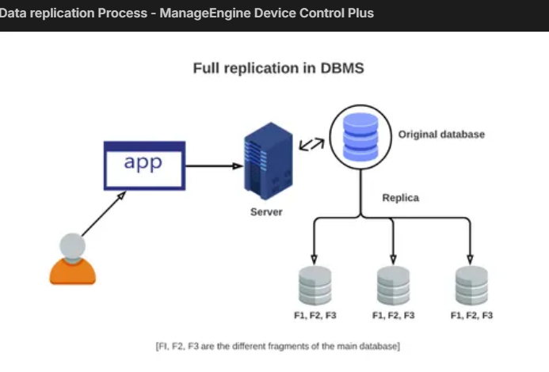

  - Cache
With the help of cache we have revoke the extra database calls.
That why we implement database call

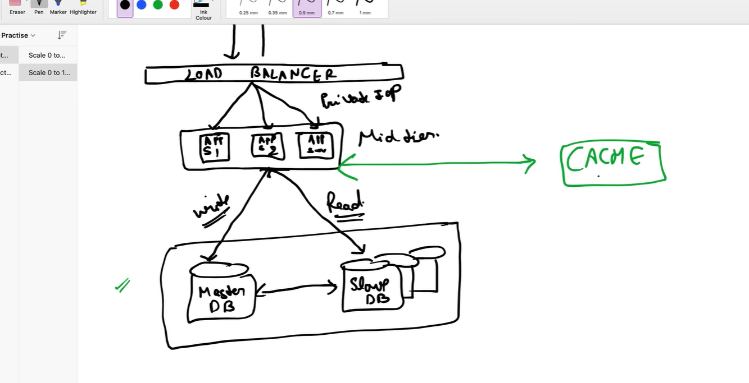

When we implement the cache the TTL is being settled (Time to live)
It can be for 24 hours or for seven day after that cache get automatically settled.

Consistent Hashing ;-

